THE CENTRAL BANK

OF THE REPUBLIC OF ARMENIA

Approved under Board of the Central Bank Resolution No. 244A,

dated November 20, 2015

Inflation Report

Monetary Policy Program, Q4, 2015

⬅

Status Report on Implementation of the Monetary Policy Program, Q3, 2015

Table of Contents

1. Executive Summary......................................................................
2. Forecast, Forecast Changes and Risks.........................................
2.1. External environment.............................................................

2.2. Aggregate supply and aggregate demand................................

2.3. Inflation forecasts and monetary policy directions in 3-year forecast horizon.....................................................................
3. Actual Developments in Q3, 2015................................................

3.1. Inflation..................................................................................

3.1.1. Actual inflation and fulfilment of the inflation target...............

3.1.2. Import prices and producer prices.........................................

3.1.3. Inflation and interest rate expectations..................................

3.2. Aggregate supply and aggregate demand................................

3.2.1. Aggregate supply.................................................................

3.2.2. Aggregate demand..............................................................

3.2.3. Labor market.....................................................................

3.2.4. Fiscal policy.......................................................................

3.3. Money and financial market developments............................

3.3.1. Financial market, money and credit.....................................

3.3.2. Exchange rate....................................................................

3.4. Balance of payments.............................................................

3.4.1. Current account.................................................................

3.4.2. Capital and financial account..............................................

3.5. External environment............................................................
4. Conclusion.................................................................................

Starting from January 2006, the Central Bank of Armenia has moved to a fully-fledged inflation targeting strategy, which highlights the importance of communicating of the Bank to the general public by publishing, inter alia, quarterly inflation reports. First section of the inflation report includes next quarter’s monetary policy program that provides new forecasts of inflation and other macroeconomic indicators and main directions of the monetary policy in the forecast horizon. Second section includes status report on implementation of the monetary policy program of the previous quarter, which covers actual economic and monetary developments.
Publishing of inflation forecast and assumptions underlying it makes the monetary policy of the Bank more transparent, understandable and predictable, which considerably increases the public confidence in the Bank. The Bank believes that a clear and trusted monetary policy positively affects the anchoring of inflation expectations and maintaining financial stability in terms of cost reduction.
Starting from the second quarter of 2012, the Bank has been publishing forecasts of non-conditional inflation in a 3-year time horizon, in implementation of the inflation targeting strategy, whereby the monetary policy is steered to minimize any deviations of potential inflation from a 4 % target.
Projections in this report are based on the factual information available by November 10, 2015, i.e. the day on which the refinancing rate was set, the results of a survey conducted by the Bank and the judgment made pursuant to the information on future macroeconomic developments​​.
All inflation reports which have been published to date are available on the Bank’s website which also contains monetary policy-related publications.

1. Executive Summary

According to the forecasts of the Central Bank of Armenia (hereinafter “the CBA”), by the end of 2015 the 12-month inflation rate will be in the lower bound of the confidence band of 4% + 1.5 pp. In the upcoming months, it will remain at a low level, gradually approaching and stabilizing around the target within forecast horizon. Year 2015 will end with a 3.2 - 3.9% economic growth which will slow down in 2016 mainly due to expected deceleration in growth rates in agriculture and industry sectors. Starting from 2017, concurrent with rebounding domestic demand, economic growth rates will speed up, gradually, approaching a long-term equilibrium.
By the end of 2015, the 12-month inflation rate will be in the lower bound of the confidence band of 4% + 1.5 pp; in the upcoming months, it will remain at a low level, gradually approaching and stabilizing around the target within forecast horizon.
Economic growth in the period January-September 2015 is predicted within 3.4 - 3.6%.

In the period January-September 2015, economic growth is expected in the range of 3.4 - 3.6%, which exceeds expectations owing to higher-than-expected output volumes in industry and agriculture sectors. Domestic demand has decreased due to noticeable reduction in real disposable household income because of shrinkage in money transfers from Russia, weak activity in construction sector and slowed down lending growth rates. The diminishing of demand in the past nine months has been mitigated as the Government continued implementing expansionary fiscal policy and the CBA had eased monetary conditions considerably since the beginning of the year (lombard repo facility rate was reduced to 12% from 20% and refinancing rate to 9.75% from 10.5%). In the third quarter of 2015, the decrease in private consumption costs is estimated to reach 7.0% and private investment costs, 10.0%. In the third quarter, net exports in real terms continued improving thanks to a real growth of export of goods and services by 21.4% y/y and a real decrease of import of goods and services by 8.5% y/y.
According to short-term forecasts of the CBA, year 2015 will end with private consumption and private investment reducing by 6.0% and 5.0%, respectively. This will be largely determined by around 30% reduction in net money remittances of individuals in dollar terms in the same period. The fiscal impulse, calculated in relation to the previous year, is estimated to be 2.0 - 2.5 expansionary for the year. This is expected to mitigate the reduction of private spending in 2015, concomitant with the easing of monetary conditions. In 2015, reduction of import of goods and services in real terms will be within 7.0 - 9.0% as a result of shrinking of domestic demand. Despite persisting weak demand in global economy during the year, the growth of export of good and services in real terms is predicted in the range of 13.0 - 15.0%, which is determined by increased productivity in tradable sector of Armenian economy and excess supply in agriculture and mining sectors. In the outcome, current account will improve notably in 2015 to reach 3.0 - 4.0% of GDP. This development helped the currency market gain its equilibrium. The exchange-rate-driven inflationary expectations are therefore forecast to continue easing, which will facilitate the reducing of inflation netof seasonally adjusted food products and regulated services.
Economic growth in 2015 is estimated in the range of 3.2 - 3.9%, which will be driven largely by growth of net exports.
As a result, economic growth in 2015 is estimated to be within 3.2 - 3.9%, which will be driven largely by growth of net exports. Relative to the previous forecast, the growth has been revised slightly upside thanks to higher-than-expected growth being reported in industry and services rendered.
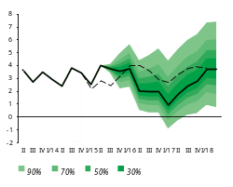
In 2016, economic growth rates will slow down. Starting from 2017, the growth rates will speed up, carrying the influence of effective implementation of the Government program steered to export and investment promotion, gradual improvement in the external economic environment and structural reforms. Driven by these developments, it is expected that economic growth at the end of the forecast horizon will be within 3.0 - 4.5%.
Real GDP Cumulative Growth Projection Probability Distribution Chart for a 3-year horizon
August 2015 projection
Current projection
Economic growth rates will slow down in 2016 but are predicted to accelerate starting from 2017. At the end of the forecast horizon, growth will be within 3.0 - 4.5%.
Thus, in the forecast horizon, private demand will gradually stabilize and help the economic growth bounce back. However, demand in the private sector will be lower from its equilibrium. Taking into account the influence of the fiscal policy, domestic demand will retain deflationary pressures in the consumer market in the forecast horizon. In the period 2015 - 2017 however, such deflationary pressures will be eased by inflationary impact of net exports and will phase out at the end of the forecast horizon.
In the third quarter of 2015, economic landscape in Armenia’s main trade partners was as follows: the USA and Eurozone further demonstrated slow-growth patterns, while Russia posted even deeper economic decline. In the third quarter, international markets of basic commodities remained deflationary owing to a low level of global demand as well as expectations about large production volumes.
In the third quarter of 2015, the USA and Eurozone further demonstrated slow-growth patterns, while Russia posted even deeper economic decline.
On the back of low global demand, commodity and food product markets will further demonstrate deflationary patterns in the short run. Then, as the global demand rebounds, some recovering of prices can be anticipated. So, in the forecast horizon inflationary pressures from the external sector are not anticipated.
Commodity and food product markets will further demonstrate deflationary patterns in the short run. In the forecast horizon, inflationary pressures from the external sector are not likely.
At the start of forecast horizon, financial and economic risks which derive from global economy and main trade partners of Armenia and which are transmitting to the Armenian economy will persist. Such risks will however phase out in the medium run when economic growth in partners’ countries recovers, prices in commodity and food product markets stabilize and volatility in world financial markets eliminates.
In the third quarter of 2015, the 12-month inflation rate sloped down to 3.3% at the end of September, which was almost entirely due to agricultural products that reported lower prices in comparison with the same reference period last year.
In the third quarter of 2015, the 12-month inflation rate followed a down-sloping path, consistent with the projection, reaching 3.3% in late September and decreasing further to 1.9% in October. The decrease was almost entirely due to agricultural products that reported lower prices in comparison with the same reference period last year. However, in the face of weak domestic demand and deflationary external environment, prices net of seasonal agricultural products demonstrated downside rigidity, pointing to still high inflationary expectations. Considering that the inflationary environment is currently low and no inflationary effects from weak external and domestic demand are discernable, the CBA loosened monetary conditions by lowering the refinancing rate by 0.25 pp to 10.25% in August (see details in section “3.1.1 Actual inflation and fulfillment of the inflation target”).
Despite weak domestic demand and deflationary external environment, product prices netted from seasonal agricultural products displayed downside rigidity, pointing to still strong inflationary expectations.
The CBA loosened monetary conditions by lowering the refinancing rate by 0.25 pp to 10.25 pp in August.
According to the CBA estimates, at the end of 2015 the 12-month inflation rate will be at the lower bound of the confidence band; in the upcoming months it will persist at a lower level but is predicted to approach and stabilize around the target in the forecast horizon.
2015 Ã. í»ñçáõÙ 12-³ÙëÛ³ ·Ý³×Á Ï·ïÝíÇ ï³ï³ÝáõÙÝ»ñÇ ÃáõÛÉ³ïñ»ÉÇ ÙÇç³Ï³ÛùÇ ëïáñÇÝ Ñ³ïí³ÍÇ ßñç³Ï³ÛùáõÙ, ÇëÏ Ñ»ï³·³ ³ÙÇëÝ»ñÇÝ Ïå³Ñå³ÝíÇ ó³Íñ Ù³Ï³ñ¹³ÏáõÙª Ï³ÝË³ï»ëíáÕ ÑáñÇ½áÝáõÙ ³ëïÇ×³Ý³µ³ñ Ùáï»Ý³Éáí ¨ Ï³ÛáõÝ³Ý³Éáí Ýå³ï³Ï³ÛÇÝ óáõó³ÝÇßÇ ßáõñç:
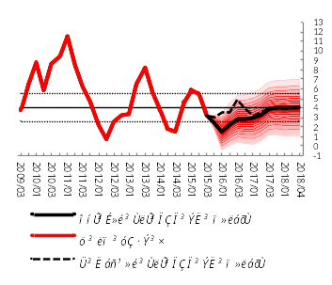
At the end of 2015, the 12-month inflation rate will be at the lower bound of the confidence band; in the upcoming months it will persist at a lower level but is predicted to approach and stabilize around the target in the forecast horizon.
Inflation (12-month) Forecast Probability Distribution Chart for a 3-year horizon

As inflationary expectations diminish, the inflation indicator net of agricultural products will subdue as well. The direct impact from electricity tariff increase since August 1 of this year has not been considered in inflation forecasts in view of an announcement by the Government and “Electric Networks of Armenia” CJSC to subsidize the electricity price for a particular part of population and small businesses up until August next year as well as any further uncertainties relevant to this development. At the same time, the indirect impact of electricity tariff increase on inflation through an increased cost of a number of goods has been small, i.e. consistent with the CBA projections, and additional inflation risks related thereto are not likely. The inflationary effect of possible changes in excise taxes in 2016 has been considered in inflation forecasts.
The CBA reckons that loosening of monetary conditions in the fourth quarter of 2015, which could otherwise be sharper in case of low inflationary expectations, will result in expansion of aggregate demand and stabilization of inflation around the target in the forecast horizon. On November 10, 2015, the CBA cut the refinancing rate by 0.5 pp to 9.75%. In the fourth quarter, the CBA will keep on easing monetary conditions in the event inflation expectations are anchored and additional inflationary risks from both external and domestic environments are lacking.
The CBA estimates that loosening of monetary conditions in the fourth quarter of 2015, which could otherwise be sharper in case of low inflationary expectations, will result in expansion of aggregate demand and stabilization of inflation around the target in the forecast horizon.
Risks to inflation deviating from the projected value are estimated balanced in both short and medium-term perspectives. Risks deriving from the external sector are related to economic outlook in both developed and developing countries. In particular, there is risk that an expected hike in interest rates by the U.S. Federal Reserve System could lead to capital outflows from developing countries to the U.S.A. and provoke higher volatilities of currencies in developing countries. More pronounced are the risks to the further developments in Russian economy. These are attributable to oil prices with their deeper-than-expected decline and predicted lower level in the forecast horizon, continued depreciation of the Russian ruble, and a further course of geopolitical developments. A sharp slowdown in Chinese economic growth could also pose risks to the global economic decline and the fall in international prices of commodities and food products. Risks deriving from the domestic sector are dual-sided and mostly associated with the developments in agriculture, a sector greatly depending on weather conditions, the pace at which domestic demand and private investments will recover, as well as Government-led promotion programs. If the aforementioned risks materialize, the CBA will react accordingly by maintaining the inflation target in the medium run.
2. Forecast, Forecast Changes and Risks

2.1. External environment

Trends of slow economic growth will be observable in principal trade partner countries. An exception is Russia where declining in growth rates are still anticipated. Economies will continue to grow slowly in developed countries, while developing countries will see deceleration in growth rates.
In external markets, deflationary patterns will be persisting in the short run due to weak global demand and excess supply in individual commodity markets. However, prices are anticipated to grow moderately in the medium run as the global demand rebounds gradually.
Economic growth in the USA in 2015 is estimated at around 2.5%; such growth rate will persist over 2016 and stabilize around 2.2% in the forecast horizon. The anticipation is that the US Federal Reserve System will raise the policy rates starting from December 2015, as the US labor market continues improving and the unemployment rate reduces notably. Albeit at a low level, the inflation is expected to approach its target of 2% level in the medium run.
Economic growth in Eurozone in 2015 is predicted at around 1.4%, which will speed up to 1.7% in the forecast horizon. Inflation is still below its target level and will only come up to it at the end of the forecast horizon. The anticipation is that the European Central Bank will continue its low-interest-rates policy and quantitative easing program up until the end of 2016, which is aimed at restoring economic activity and regulating inflation.
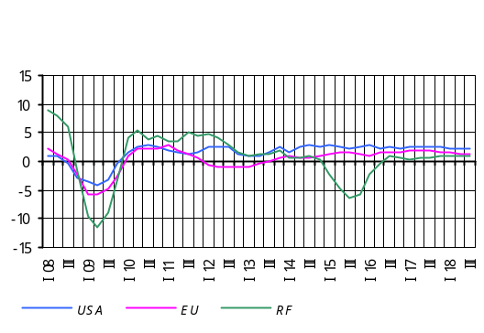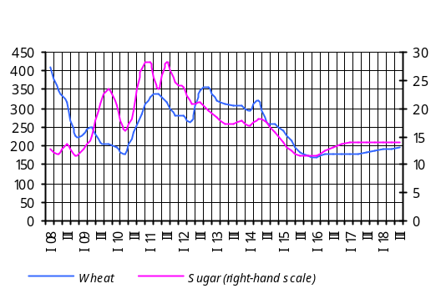In 2015, economic decline in Russia will continue; at the end of the year it will amount to -4.7% on average. It was revised downside relative to the former forecast driven by estimation of deeper-than-expected decline in the third quarter of 2015. Recovering of the economy will only be expected at the end of 2016 – at the end of the forecast horizon the economic growth will reach 0.8%. Low oil prices and persisting economic sanctions will continue determining weak economic activity. Continued decline in oil prices will keep the Russian ruble depreciated at the end of the year, while inflation will persist at a high level, amounting to 13-14%. However, the inflation may subdue to a certain extent and exchange rate trend steadier in the medium run: at the end of 2016 the inflation will reach 7% and in the forecast horizon it could approach a 4% target set by the Central Bank of Russia.
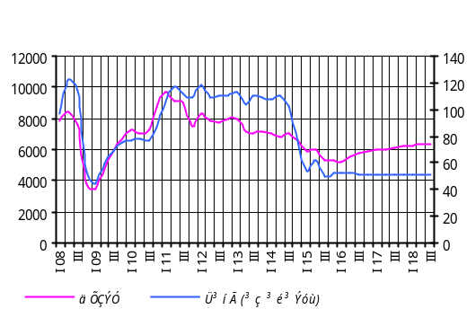 In addition, the IMF October 2015 report predicted a 3.1% growth of global economy for 2015 and a 3.6% growth for 2016 (these are, respectively, 0.2 pp of downward revisions in comparison with the July release of the report).
With industrial output increasing and global demand still sluggish, deflationary trends in world commodity and food product markets will continue up until the start of 2016. However, a small growth to recovered prices in the forecast horizon is likely on the back of rebounding global demand. Note that oil prices will remain low up until the end of the forecast horizon, following an expected increase in industrial output and greater amount of inventories in the market due to Iran’s entry to the oil market.
Risks to the developments in global economy are much the same compared to the previous forecast. In particular, positive risks related to persistently low prices in commodity and food product markets will continue pushing global demand up. On the other hand, Iran entering the oil market continues to be a significant risk since prices may fall steeply in the short term and persist at a very low level in the medium term. Development perspectives in Chinese economy are further shaping risks to the global economic slowdown and the fall in international prices of commodities and food products. Risks to the oil markets and economic developments in Russia, associated with the geopolitical tension in the Middle East and Ukraine, will persist, too. Increasing of interest rates by the U.S. Fed still contains uncertainties in terms of further capital outflows from developing countries and heightened volatility in financial and foreign exchange markets.
Financial and economic risks being transmitted to the Armenian economy as a result of developments in global economy and principal trade partners’ economies will persist at the beginning of the forecast horizon. Such risks will phase out as economic growth in partner countries recovers, prices in commodity and food product markets stabilize and volatility in world financial markets eliminates in the medium-term perspective.

Box 1

Developments in commodities markets
in the forecast horizon

The October 2015 report of the oil market published by the OPEC predicts that the global oil demand will grow in 2015 by 1.5 million b/d and consumption will reach 92.86 million b/d. The report also foresees that oil production outside OPEC in 2015 will average 57.24 million b/d (0.72 million b/d more in comparison with the previous year). Oil production by OPEC in 2015 will go up by 0.19 million b/d against the previous year. It is expected that Iran’s entry into oil product markets would lead to an additional increase in market supply in 2016, in which case a low level of oil prices can be anticipated throughout the forecast horizon.
Increased production volumes in metals markets on the one hand and an abrupt slowdown in China’s industrial sector on the other will lead to low prices of metals in world markets.
According to October estimates of the U.S. Department of Agriculture, in the 2015/2016 marketing year some 732.8 million tons of wheat crops is expected (731 million tons in the previous marketing year). The world wheat stock is now an estimated 228.5 million tons compared to 226.6 million tons in the previous marketing year. The increasing of the supply will determine a low price environment in the short run.
World rice production in the 2015/2016 marketing year is estimated to reach 474.0 million tons. According to U.S. Department of Agriculture estimates, rice stocks in the 2015/2016 marketing year will total 88.3 million tons, down by 1.9 million tons, due to unfavorable weather conditions. In a short-term perspective, international rice prices will tend to decrease further in response to reduced world demand for rice.
International sugar prices are predicted to go up in the medium run in consideration of reduced crops in Brazil, the world’s leading manufacturer and exporter of sugar cane, and shrinking production volumes in India and Thailand due to adverse weather.
In general, prices of food products are expected to drop in a short-term perspective and remain at a lower level against a former forecast.

2.2. Aggregate supply and aggregate demand

Aggregate supply
Economic growth forecasts for 2015 have been revised slightly upside due to higher-than-expected value added reported in industry and services sectors in the first half of the year. As a result, economic growth in 2015 is anticipated in the range of 3.2 - 3.9%. It should be mentioned that with domestic demand diminishing, economic growth in 2015 was driven by net exports which have grown thanks to structural reforms implemented in recent years, favorable developments in agricultural sector as well as Armenian dram’s depreciation against the U.S. dollar at the end of 2014.
Anticipated rebounding of growth rates in money transfers from Russia, reviving of economic activity to some extent in partner countries in 2016 as well as a lagged impact of loosened monetary policy carried out in 2015 all will contribute to the expanding of domestic and external demand. Though the domestic demand is expected to increase gradually, spending in the economy in 2016 will still be sluggish. Also, given probable slowing of growth rates in agriculture and industry sectors, economic growth in 2016 is estimated to be within 1.6 - 2.7%.
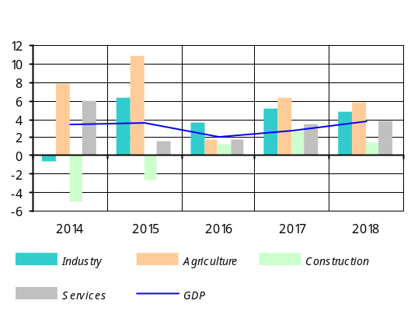Effective implementation of export and investment-oriented program of the Government, improving external economic environment and structural reforms are among key factors that will accelerate the economic growth, starting from 2017, amid a steady inflation environment. Based on the above mentioned developments, it is expected that economic growth will speed up and be in the range of 3.0 - 4.5% at the end of the forecast horizon, which will further be driven greatly by the tradable sector.
Given reduced long-term economic growth equilibriums amid growing uncertainties associated with further economic developments in Armenia’s main trade partners, anticipated slowing of foreign capital investment, and weak investment activity persisting in the domestic economy, Armenia’s long-term economic growth equilibrium is estimated within 4 - 5%. It should be noted, however, that the aforementioned GDP growth rate may decelerate if investment in tradable sector of the economy remain slow.
For Industry, the forecasts of value added have been revised upside, mostly due to higher-than-expected growth rates in mining sub-industry in the first half of the year.
Thus, in 2015 value added in industry is predicted to be within 6.0 - 6.4%. Exploiting of Teghout mine and identifying new export markets has significantly contributed to the progress in industry during the year.
In the forecast horizon, the industry growth will stabilize within 4.0 - 5.5%. This will be underpinned by implementing a handful of investment projects and broadening export capacities as the Government carries out an export-oriented policy.
For Construction, the forecasts of value added have been revised downside, mainly based upon a smaller indicator in relation to expected growth rates in value added in the first half of the year. In view of low investment activity in non-tradable sector of the economy, there is anticipation that volumes of construction funded by organizations would shrink. Taking also into account contracting volumes of construction funded by public expenditures, reduction in value added in total construction in 2015 is estimated in the range of 2.0 - 3.0%.
In the forecast horizon, the growth is expected to stabilize within 1.0 - 2.0% as the supply and demand imbalance in construction phases out. The growth will be driven mainly by large construction projects designed for infrastructure improvement and investment projects in private sector.
For Services, the forecasts of value added have been revised slightly upside, owing to higher-than-expected growth rates in services rendered. Thus, the real growth of value added of services in 2015 is expected within 1.4 - 1.8%. Note that the expected growth is well below the average growth indicator recorded for services in recent years. The slowing in the branch is primarily due to contraction of trade and trade-related services because of weak domestic demand. This, however, contributes to the adjustment of existing imbalances in the economy and sustainability of future economic growth.
In the forecast horizon, growth in services is predicted to speed up and stabilize around 3.5 - 4.5% in expectation of gradual recovery of domestic demand and tourism growth.
For Agriculture, the forecasts of value added remained unchanged relative to previous predictions (10.5 - 11.5%). The growth is expected as a result of above-average performance in plant growing observable in the last few years, which had been driven by rather favorable weather conditions. The sector has been fueled by strong fishing activities and moderate growth in animal breeding, which are anticipated to persist over the fourth quarter of the year.
In the forecast horizon, the growth in agriculture will stabilize in the range of 5 - 6%. Relatively high growth rates in the medium run will be possible to maintain by using more house farming and refrigerator facilities, arable land, crops and cattle, and engaging extra means of transportation for exports, as a result of consistent complex measures which the Government has taken on in recent years.
In the forecast horizon, risks to the economic growth for 2015 are dual-sided and balanced. These are associated with industry growth underpinned by abundant crop provisioning and processing on the one hand and uncertainties over growth rates in services amid diminishing demand on the other.
Real GDP Cumulative Growth Projection Probability Distribution Chart for a 3-year horizon
August 2015 projection
Current projection
In the forecast horizon, risks to the economic growth are dual-sided, too, but upside risks are prevailing. These are associated with uncertainties in global and domestic economic environments. Among them, most prominent are the expanding and using of export potential in industry amid gradual recovery of global economy and growing competitiveness of Armenia, as well as maintaining the 2015 strong growth rates in non-commercial services in the medium run. Downside risks include a possible contraction of agricultural output in 2016 attributable to the base effect of a record amount of harvests in 2015.

Real GDP Growth (Cumulative) Projection
Probability Distribution
Period | 30% probability interval |  | 90% probability interval
Period | Minimum | Maximum | Minimum | Maximum
January-December 2015 / January-December 2014 | 3.2% | 3.9% | 2.2% | 5.0%
January-December 2016 / January-December 2015 | 1.6% | 2.7% | 0.3% | 5.3%
January-December 2017 / January-December 2016 | 2.2% | 3.7% | 0.2% | 6.4%
January-December 2018 / January-December 2017 | 3.0% | 4.5% | 0.6% | 7.4%

Labor market: Forecasts of labor market indicators for 2015 remained unchanged. However, forecasts of relevant indicators for 2016 - 2018 have come in somewhat worsened, reflecting the adjustment in economic growth forecasts and anticipated small rise in wages in the public sector in 2016. Specifically, in the forecast horizon, average wage is expected to report higher growth rates. Thus, average nominal wage is predicted to grow by 9.2% in 2015, by 5.4% in 2016 and by about 7.0% in 2017 - 2018.
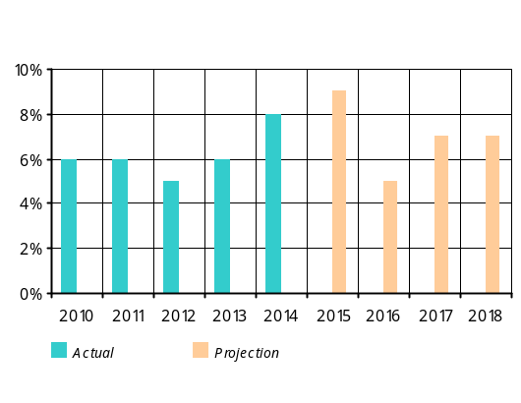The impact of wage increases in the public sector from July of 2014 has abolished since the second half of 2015. Until yearend, public wages are predicted to grow at a rate close to average wage growth rates reported in the sector in recent years, which is relatively low from growth rates observed in the first half of the year. High growth rate in wages in the private sector will persist up until the end of the year, amounting to 7.7% on average for 2015. Note that the minimum wage threshold has risen to AMD 55,000 since July of 2015. As a result, the average wage growth for 2015 is predicted to reach 9.2%.
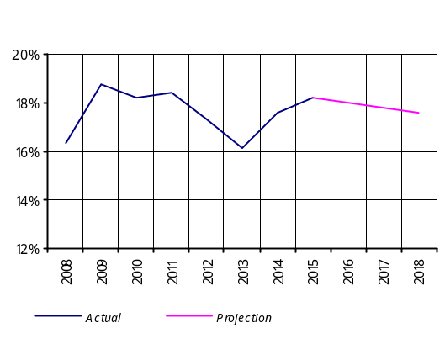In 2016, average nominal wage is expected to grow by 5.4% as there will be less economic growth in 2016 compared to former forecasts, nor will the minimum wage threshold increase during the year. With an expected economic growth, stabilizing inflation rate and the Government policy taking up again to increase minimum wages starting from 2017, the average nominal wage is predicted to grow by 7.0% annually in the period 2017-2018.
Despite acceleration of economic activity, the 2015 unemployment forecast remained almost unchanged in comparison with previous forecasts because of increased productivity observed in the economy. Thus, average unemployment rate in 2015 is expected to amount to 18.2%. In 2016, the growth of productivity will be neutral and minimum wage threshold stay unchanged, while aggregate demand and net exports will significicantly contribute to the economic growth in 2016 - 2018. As a result, the unemployment rate is predicted to subdue by about 0.2 pp annually in the period 2016 - 2018. It should be noted that by the second quarter of 2017, the unemployment rate will be above its equilibrium, reflecting a small negative GDP gap and minor deflationary pressures it has created. By the end of the forecast horizon, the unemployment will approach its equilibrium.
Productivity growth expected in the fourth quarter of 2015 will slightly outweigh an anticipated rise in wages and will leave some 0.1-0.2% of deflationary effect on the inflation during the quarter. In the forecast horizon, the labor market’s impact on inflation is estimated to be neutral.

Aggregate demand
In view of persisting decline in remittances from Russia, a trend observable since the start of the year, and weak investment activity in the domestic economy, private sector spending in Armenia is anticipated to delcine in 2015 by nearly 6.0%. Furthermore, private sector may anticipate even a greater contraction of its expenditures during the year as private consumption diminishes more in comparison with previous forecasts.
A tight monetary policy carried out in late 2014 to maintain price and financial stability was altered in early 2015 with the one in order to ease monetary conditions. This allowed to mitigate the declining level of private spending in 2015 while avoiding an abrupt adjustment of the economy and securing macroeconomic stability.
An expansionary fiscal policy implemented in 2015 made the declining of domestic demand, which in its turn was driven by diminished incomes in private sector, and its adverse impact on economic growth less painful.
The domestic demand will increase gradually in 2016 - 2018 as economic activity revives in trade partner countries as well as the lagged impact of the aforementioned expansionary policies in the Armenian economy persists.
Though weak domestic demand will negatively affect the economic growth at the start of the forecast horizon, it will however facilitate the elimination of imbalances observable in the domestic economy in recent years, which includes, specifically, adjusting of the negative current account. This, in a floating exchange rate regime, increases the tradable sector of the Armenian economy, strengthens the macroeconomic stability and creates conditions for sustainable long-term economic growth.
Armenia’s economic growth in 2015 was achieved primarily by contributing to net exports, which is determined by more rapid productivity growth rates in tradable sector of the Armenian economy as a result of improved competitiveness. Given the global demand expands and investments in tradable sector increase in 2016 - 2018, net exports will continue to largely contribute to the economic growth. In the forecast horizon, revenues generated in the tradable sector will, in turn, serve a source to finance gross private expenditures and will promote the recovery of the domestic demand and economic growth on the whole.

Private sector spending
Estimates suggest that final consumption expenditures of households will reduce in 2015 by around 6% in real terms as a result of considerable reduction in remittances from Russia and slowed down growth rates of credit to the economy. The shrinkage of private consumption is estimated to be higher compared to previous forecasts, which is attributable to the second quarter’s private consumption having contracted more compared to former forecasts, as well as deteriorating situation in the Russian economy.
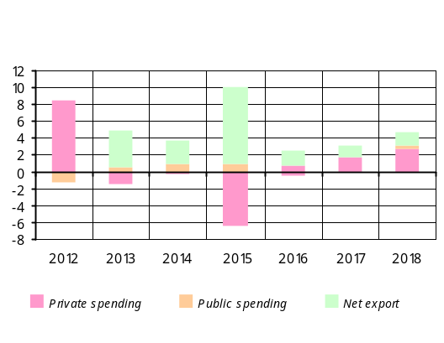The above factors, as well as current and expected sluggishness in investment activity will lead to about 5.0% reduction in private investment in 2015, which is consistent with previous forecasts.
An expected decline in private investment in 2015 will be determined by reduced investment in companies engaged in construction and other non-tradable sectors of the economy, which will outweigh investments in the tradable sector. An expected growth of investments in the tradable sector is due to relatively high profitability there as a result of the dram exchange rate depreciation in late 2014, as well as increased external competitiveness of the domestic economy driven by structural reforms.
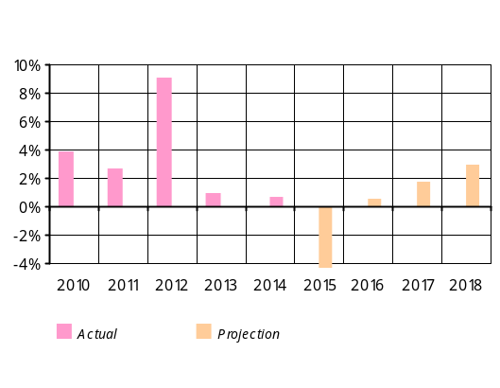 The 2015 expansionary fiscal policy, considerable easing of monetary conditions since the beginning of the year and current steady inflationary environment will cushion the decline in private consumption and investment in 2015 and even stimulate their growth in 2016 - 2018. Improving external economic environment and Russia’s economic recovery in particular may positively contribute to this process. As a result, the growth of private consumption is expected to be slower in comparison with former forecasts and will be in the range of 0.3 - 0.9% in 2016, 1.3 - 2.1% in 2017 and 2.5 - 3.5% at the end of the forecast horizon.
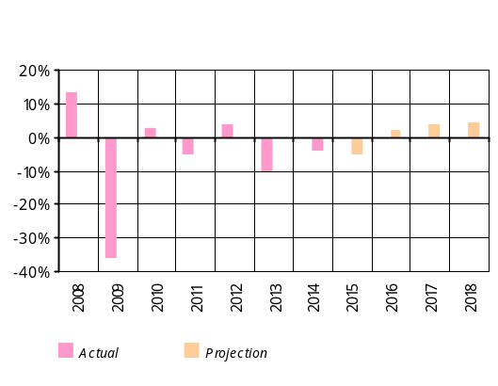Anticipated growth indicators of private investment (1.8 - 2.3%, 3.6 - 4.4% and 4 - 5%) in the above mentioned period of forecast horizon have not changed notably in relation to previous forecasts. A moderate growth of investments can be expected as a result of investments in the tradable sector and continued implementation of structural reforms in the domestic economy. On the back of these developments, investment activity in non-tradable sector is expected to recover in 2016-2018, although rather slowly than it is envisaged in tradable sector.
In view of the aforementioned developments with private consumption and investment, in 2015 private sector expenditures will reduce by 6.2%. Starting from 2016, private spending will gradually recover, growing in the range of 0.6 - 1.2%, and at the end of the forecast horizon it will stabilize within 2.5 - 3.5%. As a result , private spending gap for the period 2015 - 2016 is estimated to be negative despite the fact that the level of private spending rebounds gradually in the forecast horizon.
An expansionary fiscal policy to be implemented in the domestic economy, consistent easing of monetary conditions, as well as acceleration of economic growth in principal trade partner countries will gradually reduce the negative private spending gap and help this imbalance phase out at the end of the forecast horizon.
In the time-span of the fourth quarter of 2015 to the first quarter of 2017, concurrent with stabilizing inflationary expectations which are currently heightened, the private spending will create some 1.3 - 1.4 pp of contractionary impact on the inflation. From the second quarter of 2017 up to the end of the forecast horizon, the private spending will leave no considerable impact on the inflation.

Current account
Estimation of the Current Account Deficit-to-GDP ratio for 2015 has improved on the back of positive developments in the domestic industry sector and actual developments with current account in the first half of 2015 in spite of new forecasts of economic downturn in Russia. At the end of 2015, the Current Account Deficit-to-GDP ratio will be in the range of 3.0 - 4.0% instead of the July forecast of 4.0 - 5.0%. In the time of negative developments with private transfers, the current account will improve primarily due to improvement of balance of trade. In 2015, export growth of goods and services in real terms will be in the range of 13.0 - 15.0% in view of less-than-expected growth of export of goods and services in the third quarter and the forecast of growth rates revised slightly downside for the fourth quarter. In 2015, the rates of decline in real import of goods and services will be higher in comparison with the former forecast, within 7.0 - 9.0%. This will be attributable to even deeper declining rates reported in the previous quarter and the downside revision of the fourth quarter’s forecast. The shrinking of the value of remittances of individuals will reach 30.0% at the yearend amid high depreciation of the Russian ruble in the third quarter and the downside revision of the fourth quarter’s forecast.
Anticipated sluggishness of global demand in 2016, low prices of metals, decelerating growth rates in industry all will result in the predicted slowing of growth rates in export of goods and services to 3.0 - 5.0%. The real shrinkage of import of goods and services is forecast within 2.0 - 4.0%, which is conditioned by persisting weak domestic demand.
Given that economic slump in Russia continues, growth rates in remittances of individuals in 2016 can be expected at zero.
In consideration of the forecasts mentioned above, the Current Account Deficit-to-GDP ratio for 2016 will persist at the current year’s level of 3.0 - 4.0%. The improving of current account will mainly be through contracting trade balance deficit; in the medium run it is predicted to persist in the range of 3.0 - 4.0%.
In the forecast horizon, the impact of net external demand is estimated to be 0.2 - 0.3 pp inflationary, which will phase out at the end of the forecast horizon.
The fiscal policy’s impact on aggregate demand for 2015 has been assessed using the 2015 expected indicators of the draft law to the Republic of Armenia Law on “State Budget 2016”. The assessment predicts a decrease of the Tax-to-GDP ratio and an increase of the Expense-to-GDP ratio against the 2014 indicators, owing to both current and capital expenditures. As a result, the Deficit-to-GDP ratio in 2015 will be 3.8%, which is much higher from the figure of 2.34% as provided for in the budget law.
In 2015, relative to 2014, budget revenues are projected to leave 0.95 and budget expenditures 1.0 of expansionary impact on the aggregate demand.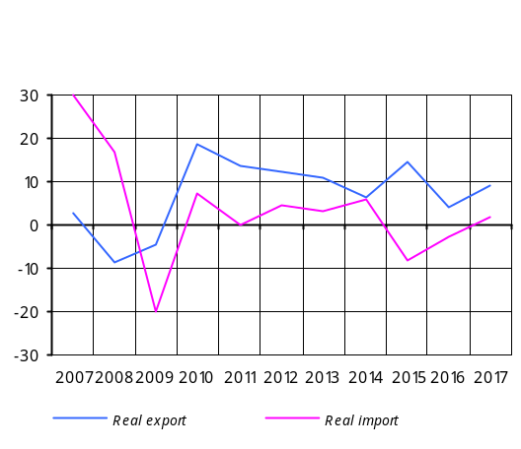 Moreover, the fourth quarter of the year may expect a much smaller expansionary impact than in the past three quarters, so the assessment of the expansionary impact of the fiscal policy on aggregate demand is again in the range of 2.0 - 2.5 for the year.
The projections of the fiscal policy in the forecast horizon are based on the figures in the draft law on the state budget 2016. The Tax-to-GDP and Expense-to-GDP ratios are predicted to decrease against the 2015 forecasts by 0.2% and 0.5%, respectively. Based on annual results, the fiscal policy will have a contractionary impact of 1.0 - 1.3, which will be mostly determined by contractionary effect of expenditures. The public sector’s impact estimated on the basis of macroeconomic indicators in the Republic of Armenia Medium-Term Public Expenditures Program for 2016-2018 will be contractionary in 2017 and neutral in 2018.
The fiscal policy’s expansionary impact on aggregate demand remains within 2.0 - 2.5 for the year.

Medium-term fiscal policy impact assessment
% in GDP | 2014 | 2015 | 2016 | 2017 | 2018
Budget revenues | 22.8 | 21.9 | 21.7 | 22.3 | 22.4
Budget expenditures | 24.7 | 25.7 | 25.2 | 24.2 | 24.0
Debt interest payment | 1.2 | 1.5 | 1.8 | 1.8 | 1.7
Budget balance | -1.9 | -3.8 | -3.5 | -1.8 | -1.6
Primary balance* | -0.7 | -2.3 | -1.7 | -0.1 | 0.1
One-off flows** | -0.6 | 0.1 | -0.4 | -0.6 | -0.5
Adjusted balance*** | -0.1 | -2.4 | -1.3 | 0.5 | 0.6
Cyclical balance**** | 0.0 | -0.3 | -0.3 | 0.0 | 0.1
Cyclically adjusted primary balance (structural balance sheet) | -0.1 | -2.1 | -1.0 | 0.5 | 0.5
Fiscal stance***** |  | 2.0 | -1.1 | -1.5 | 0.0
* Budget balance less debt interest payments.
** Temporary or one-off budget entries. In this case net lending is considered; the sign “+” means resources allocated and the sign “–” means resources repaid.
*** Primary balance sheet adjusted by temporary or one-off entries.
**** Central Bank estimate: a part of the budget balance which depends directly on the business cycles. The latter’s components depend on the GDP gap and revenues and expenditures elasticity coefficients on GDP gap.
***** Central Bank estimate: y/y change in the structural budget balance that reflects a discretionary nature of the fiscal policy (the positive sign denotes fiscal expansion and the negative sign denotes fiscal contraction).
Summary: from the fourth quarter of 2015 up to the first half of 2017 the combined impact of the fiscal policy, private demand and labor market on domestic prices will be deflationary, in the range of 1.7 - 1.9 pp, which will be determined by predominantly deflationary impact of private spending amidst stabilizing inflation expectations. Also, given the 0.2 - 0.3 percentage point inflationary impact of net external demand, one may conclude that overall aggregate demand and labor market developments in the above-mentioned period will create an average 1.5 - 1.7 percentage point deflationary pressures in the consumer market.
Starting from the second half of 2017 up until the end of the forecast horizon, the impact of overall aggregate demand and labor market on inflation is estimated to be neutral.

2.3. Inflation forecasts and monetary policy directions in 3-year forecast horizon

In the third quarter of 2015 economic growth was slow in the main trade partners countries of Armenia. An exception was Russia with deeper than expected economic decline. In the meantime, global demand remained sluggish, which, coupled with increased supply factors, has shaped more-than-expected deflationary environmentin basic commodity and food product world markets.
In the forecast horizon, global economic growth will continue at a slow pace; while trends of improving economic growth will be observable in developed countries, growth rates will decelerate in developing countries. In view of geopolitical and domestic economic developments, the Russian economy will keep on slowing down, which will be deeper compared to theprevious forecast. In particular, a 4.7% economic decline is expected in 2015 (previous forecast: 3.2%), which will continue up to the middle of 2016, gradually approaching a 0.8% level in the forecast horizon. Meanwhile, the risks and uncertainties about further developments of the global economy, outlined in the previous forecast, will be persisting. On the one hand, they are associated with anticipation of interest rate hike by the U.S. Federal Reserve System and the consequences it could bring. On the other hand, there are significant risks related to the futuredevelopments in the Russian economy in the light of geopolitical and economic situation. Economic development prospects in China, Iran’s entry into the oil market, possible consequences resulting from the geopolitical tension in the Middle East and Ukraine all can bring significant risks.
Trends of slow improving economic growth will be observable in developed countries but growth rates will decelerate in developing countries.
With global economy still sluggish and excess supply observed in seperatecommodity markets, external markets will see even more pronounced deflationary patterns against the previous forecast, which will persist in the short run as well. However, a certain rise in international prices of basic commodities and food products can be anticipated in the forecast horizon as global demand recovers gradually.
External markets will see pronounced deflationary patterns, which will persist in the short run as well.
In the first half of 2015, domestic economic growth rates were higher than anticipated, 4.0% y/y, due to more favourable developments reported in industry and agriculture sectors. The economic growth in the third quarter of 2015 is predicted to exceed the expectations again, making up in the range of 3.4 - 3.6%. The tradable sector of the economy, the agriculture and mining sub-sector in particular, which saw a strong productivity growth at the beginning of the year, will be the main driving force of the economic growth.
In the first half of 2015, domestic economic growth rates were higher than anticipated, 4.0% y/y, due to more favourable developments reported in industry and agriculture.
In the third quarter of 2015, with the Russian ruble depreciating against the US dollar and the Russian economy further slowing down, the dollar value of net inflow of private remittances and seasonal worker payments declined at even faster rates, thus driving the previous quarter’s negative real private remittances gap to deepen substantially. With private remittances growth rates shrinking , growth rates in lending slowed down, and construction activity still sluggish, the domestic demand remained fragile during the quarter, reflecting both considerable reduction in private spending and persistently weak investment environment.(Մի ամբողջ կարևոր նախադասություն չկա, թարգմանված չէ). Meantime, under faster growth of productivity in the tradable sector of the domestic economy that secured high growth in agriculture and industry, external demand kept on improving during the quarter along with adjusting negative current account. This facilitated real export to post higher than expected growth rates amid a decrease in real volumes of import.
As a result of the above developments, the GDP gap in the third quarter of 2015 is much more negative compared to the previous forecast, whereas prices net of seasonal agricultural products demonstrated downside rigidity, pointing to still high inflationary expectations. The 12-month inflation rate subdued to a 3.3% level during the quarter (in line with the projection) and further reduced to 1.9% in October has been almost entirely due to lower prices of agricultural products, relative to the same reference period of the last year, as a result of high growth rates reported in agriculture sector.
In the third quarter of 2015, the 12-month inflation rate subdued to a 3.3% level has been almost entirely due to lower prices of agricultural products relative to the same reference period of last year.
Product prices net of seasonal agricultural products demonstrated downside rigidity, pointing to still highinflationary expectations.
In the third quarter of 2015, considering the low inflationary environment and non-inflationary pressures in the light of weak external and domestic demand, the CBA loosened monetary conditions by lowering the refinancing rate by 0.25 pp to 10.25% in August. In September, however, the CBA refrained from loosening the monetary conditions any further, so it left the refinancing rate unchanged, since certain inflation risks (expected increase of electricity tariffs and pressures in the foreign exchange market, among others) appeared in the meantime were pointing to still high inflation expectations. Carrying out such monetary policy, the CBA pursued reducing and anchoring the inflation expectations, while fulfilling the inflation target in the medium run.
The CBA loosened monetary conditions by lowering the refinancing rate by 0.25 pp to 10.25% in August.
Economic growth forecasts for 2015 have been revised upside primarily due to higher-than-expected growth rates reported in industry and services sectors in the first half of the year as well as due to the implementation of a more expansionary fiscal policy. As a result, economic growth in 2015 is predicted in the range of 3.2 - 3.9%, and the tradable sector of the economy, the agriculture and industry sectors in particular, which reported strong productivity growths at the beginning of the year, will be the main contributors to the economic growth.
Economic growth forecasts for 2015 have been revised upside. The growth is expected in the range of 3.2 - 3.9%, with tradable sector of the economy, agriculture and industry sectors in particular, remaining the main driving forces of the economic growth.
In view of actual developments as well as estimates of even deeper economic decline in Russian economy, the forecasts of the dollar value of net inflow of private remittances have been revised downside. In the outcome, in consideration of slowed down lending rates and weak activity in construction sector, private spending is predicted to shrink further during 2015, reflecting both more-than-expected reduction in private consumption and persisting sluggish investment activity. It should be noted however that expansionary fiscal policy implementation in 2015, considerable loosening of monetary conditions at the beginning of the year, as well as low inflationary environment in the economy will somehow mitigateadverse impact of private spending on the domestic demand. Given that the domestic demand remains weak while productivity maintains high growth rates in the tradable sector of the economy, there is expectation that external demand will further improve in 2015, in which case the GDP gap will still be negative in the fourth quarter of 2015.
In 2016, economic growth rates will slow down to some extent, which will be determined by more contractionary fiscal policy implementation instead of an expansionary one in 2015, as well as decelerating of high growth rates in productivity in agriculture and industry sectors. In this circumstance, economic growth in 2016 is expected in the range of 1.6 - 2.7%, which will continue to be largely driven by the tradable sector of the economy. In the period 2016 - 2018 however, the domestic demand will rebound gradually amid recovering growth rates in private remittances, improving external economic environment and implementation of a number of projects by the Government steered to the tradable sector promotion. In the meantime, external demand will continue contributing to the economic growth. In the outcome, the GDP gap, still in the negative territory, will gradually reduce in 2016 to approach zero at the end of the forecast horizon. Based on the above mentioned developments, it is expected that economic growth will speed up and stay within 3.0 - 4.5% at the end of the forecast horizon, which will be largely driven by the tradable sector of the economy. The economic growth forecasts nevertheless greatly depend on investments in private sector, the scale, directions and effectiveness of the projects carried out by the Government as well as on the developments in the external sector.
In 2016, economic growth is expected in the range of 1.6 - 2.7%, which will continue to be largely driven by the tradable sector of the economy.
Economic growth will accelerate to be in the range of 3.0 - 4.5% at the end of the forecast horizon.
In reference to the 2015 inflation developments, it should be mentioned that weak domestic demand and external deflationary environment are still slowly reflected in the inflation indicator net of net of seasonal food products and regulated services, which implies that the inflation expectations remain high. The CBA estimates however that the inflation of these products will decline, too, as the inflation expectations subside. Note also that the direct impact from electricity tariff increase since August 1 of this year has not been considered in inflation forecasts in view of an announcement by the Government and “Electric Networks of Armenia” CJSC to subsidize the electricity price for a particular part of population and small businesses up until August next year as well as any further uncertainties relevant to this development. At the same time, the indirect impact of electricity tariff increase on inflation through an increased cost of a number of goods has been small, i.e. consistent with the CBA projections, and additional inflation risks related thereto are not likely. The inflationary effect of possible changes in excise taxesin 2016 has been considered in inflation forecasts. In the light of these developments, the CBA estimates that by the end of the year the 12-month inflation rate will be around the lower bound of the confidence band; in the upcoming months it will stay at a low level but will gradually approach and stabilize around the target in the forecast horizon.
The CBA estimates that by the end of the year the 12-month inflation rate will be around the lower bound of the confidence band; in the upcoming months it will stay at a low level but will gradually approach and stabilize around the target in the forecast horizon.
The CBA estimates that easing of monetary conditions in the fourth quarter of 2015, which could otherwise be sharper in case of low inflationary expectations, will along with expansionary fiscal policy implementation result in expansion of aggregate demand and stabilization of inflation around the target in the forecast horizon. In the future, depending on developments in the domestic and external environments, the CBA will adjust its monetary policy directions in order to fulfil the inflation target in the medium run.
The CBA estimates that loosening of monetary conditions in the fourth quarter of 2015, which could otherwise be sharper in case of lowinflationary expectations, will result in expansion of aggregate demand and stabilization of inflation around the target in the forecast horizon.
Period | Inflation forecast probability distribution
Period | <1.0% | 1.0-2.5% | 2.5-5.5% | 5.5-7.0% | >7.0%
Q4, 2015 | 0.1% | 54.2% | 45.7% | 0.0% | 0.0%
Q1, 2016 | 32.9% | 46.1% | 20.9% | 0.0% | 0.0%
Q2 | 17.4% | 39.5% | 42.3% | 0.8% | 0.0%
Q3 | 10.8% | 29.8% | 55.5% | 3.6% | 0.3%
Q4 | 12.6% | 29.4% | 53.4% | 4.2% | 0.4%
Q1, 2017 | 13.7% | 27.2% | 52.3% | 5.8% | 0.7%
Q2 | 10.1% | 23.3% | 56.4% | 8.6% | 1.3%
Q3 | 5.4% | 16.5% | 59.5% | 14.4% | 3.4%
Q4 | 5.2% | 15.4% | 58.0% | 16.0% | 4.3%
Q1, 2018 | 6.5% | 16.2% | 55.6% | 15.6% | 4.4%
Q2 | 6.2% | 15.6% | 55.1% | 16.3% | 4.9%
Q3 | 6.4% | 15.7% | 54.7% | 16.3% | 5.0%

Risks to inflation deviating from the projected value are estimated balanced in both short and medium-term perspectives. Risks deriving from the external sector are related to economic outlook in both developed and developing countries. In particular, there is risk that an expected hike in interest rates by the U.S. Federal Reserve System could lead to capital outflows from developing countries to the U.S.A. and provoke higher volatilities of currencies in developing countries. More pronounced are the risks to the further developments in Russian economy. These are attributable to oil prices with their deeper-than-expected decline and predicted lower level in the forecast horizon, continued depreciation of the Russian ruble, and a further course of geopolitical developments. A sharp slowdown in Chinese economic growth could also pose risks to the global economic decline and the fall in international prices of commodities and food products. Risks deriving from the domestic sector are dual-sided and mostly associated with the developments in agriculture, a sector greatly depending on weather conditions, the pace at which domestic demand and private investments will recover, as well as Government-led promotion programs. If the aforementioned risks materialize, the CBA will react accordingly by maintaining the inflation target in the medium run.
Predictions for a decline in credit growth rates remain unchanged in the forecast horizon. The slowing, as was mentioned in the previous quarter’s monetary policy program, will be somehow offset by various lending programs under a number of international financial institutions (World Bank, Asian Development Bank, KfW Bank, European Investment Bank) carried out through the Central Bank in cooperation with the Armenian Government, and by low-interest loan projects under a handful of social programs (Housing for Youth, the National Mortgage Company, among others). In the meantime, the CBA continued easing the policy of required reserves by introducing a zero or weak mechanism of reserve requirement to long-term funds attracted by banks, which pursues a goal to increase maturities of bank liabilities.
3. Actual Developments in Q3, 2015

3.1. Inflation

3.1.1. Actual inflation and fulfilment of the inflation target
There was 1.9% deflation recorded in the third quarter of 2015 (0.2% inflation in the same reference period last year) almost entirely due to 3.9% reduction in prices of food products (total contribution to deflation: -1.9 pp.).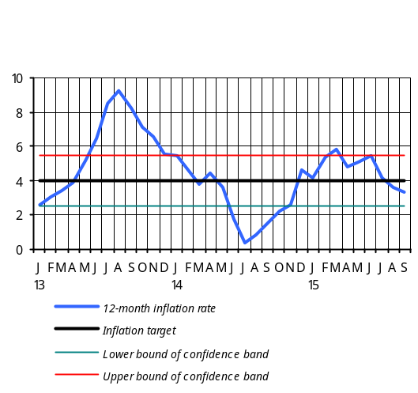 During the quarter, prices of non-food products decreased by 0.4% whereas services tariffs remained unchanged. As a result, the 12-month inflation rate, which was close to the projected level, has subdued by 1.2 pp to 3.3%.
Strong growth reported in domestic agriculture in the third quarter of 2015 pushed prices of food products down. This was primarily due to a seasonal decrease of prices of agricultural products, with the group “Fruits” having posted as much as 33.9% drop in prices (contribution to deflation: -1.1 pp.). Groups such as “Eggs”, “Dairy products” and “Meat products reported some falling of prices, with their total contribution of -0.4 pp to deflation. It should be noted that weak domestic demand and external deflationary environment are still reluctant to be reflected in the inflation indicator that is net of seasonal food products, pointing to the current high inflation expectations. Thus, the price decrease in import food groups such as “Bread products”, “Sugar”, “Fats and Oils”, “Coffee”, “Tea” and “Cocoa” has contributed to the quarter’s deflation by merely -0.15 pp.

Inflation by groups which serve as key contributors
Group | June 2015 (y/y) |  | September 2015 (y/y) |  | Third quarter of 2015
Group | Growth (%) | Contribution | Growth (%) | Contribution | Growth (%) | Contribution
CPI | 5.5 |  | 3.3 |  | -1.9
Food products | 5.2 | 2.5 | 2.3 | 1.1 | -3.9 | -1.9
Bread products | 6.2 | 0.6 | 5.3 | 0.5 | -0.6 | -0.1
Dairy products | 4.3 | 0.2 | 2.7 | 0.1 | -2.6 | -0.1
Meat products | 4.1 | 0.4 | 1.5 | 0.1 | -0.7 | -0.1
Fruits | 21.1 | 0.7 | -4.8 | -0.2 | -33.9 | -1.1
Vegetables and potato | -6.9 | -0.4 | 12.6 | 0.7 | 3.3 | 0.2
Fats and oils | -0.9 | -0.02 | -4.6 | -0.1 | -0.6 | 0.0
Egg | 4.1 | 0.06 | -16.6 | -0.3 | -11.7 | -0.2
Sugar | 3.3 | 0.03 | -2.1 | 0.0 | -5.3 | -0.04
Pastry | 18.2 | 0.2 | 14.1 | 0.2 | -0.2 | 0.0
Non-food products | 7.0 | 1.4 | 6.1 | 1.3 | -0.4 | -0.1
Services | 4.1 | 1.2 | 1.6 | 0.5 | 0.03 | 0.01
Non-food price deflation has been mainly attributable to the groups such as “Footwear”, “Detergents” and “Medicament”, with their prices fallen by 3.9%, 3.1% and 0.6%, respectively (total contribution to deflation: -0.14 pp.).
The group “Services” reported increased tariffs in education services (1.9%), rest and leisure services (1.5%) and healthcare services (0.6%). The increase has been offset to some extent by a 6.9% decrease in air transport fare.
In the third quarter of 2015, the inflation indicator net of seasonal food products and regulated services fell by 0.5% to 4.6% y/y in late September.
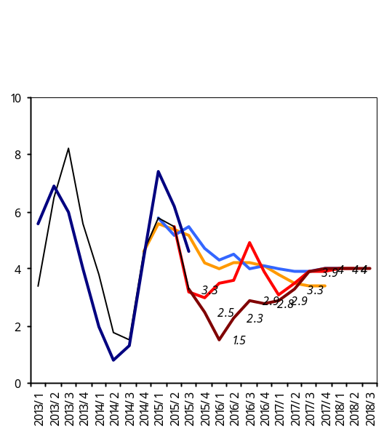
For the previous year’s short-term horizon that covers a period from 4th quarter of 2014 up to 4th quarter of 2015, the CBA predicted some expansion of the inflation environment. However, the price increase reported in December exceeded the expectations to a certain extent for the reason of anticipated local currency’s exchange rate depreciation. In the fourth quarter of 2014, the inflation was 5.4% compared to 2.3% recorded in the same reference period last year, in which case the year ended with 12-month inflation rate standing at 4.6% level. Note that more than 3.0 percentage point increase of the quarterly inflation was recorded in December when the dram incurred a steep depreciation in the foreign exchange market amid sizable reduction in the value of money transfers from abroad and Russia, a main trade partner. This event immediately affected the product market while expanding the inflation environment and shaping inflationary expectations.
12-month core inflation
Q1, 2015 forecast

.

Ï³ÝË³ï»ëáõÙ
Inflation netted from 12-month seasonal food products and regulated services
Q3, 2015 forecast

.

Ï³ÝË³ï»ëáõÙ
Q4, 2015 forecast

Ï³ÝË³ï»ëáõÙ
Q2, 2015 forecast

.

Ï³ÝË³ï»ëáõÙ
The CBA responded to the situation intensely: in late November it raised the Lombard Repo Facility Rate from 8.25 to 21.0%, followed by a mid-December increase of the Reserve Requirement Ratio for funds attracted in foreign currency from 12.0 to 24.0%. The short-term dram market rates reacted to the CBA’s tightening of conditions in the financial market by rising and staying around the Lombard Repo Facility Rate. This prompted the Lombard Repo Facility Rate to take the role of financial market’s leading interest rate. In the meantime, to moderate future inflationary pressures and have the inflationary expectations anchored around the target, in late December the CBA raised the Refinancing Rate by 1.75 pp.
Following these actions, the currency and product markets were able to see some signs of stabilization, and in late December the CBA lowered the Reserve Requirement Ratio for funds attracted in foreign currency from 24.0 to 20.0% and the Lombard Repo Facility Rate from 21.0 to 20.0%.
A strong response by the CBA at the end of 2014 secured anchoring of inflation expectations in the first quarter of 2015, which helped to almost eliminate the tension in the domestic financial and commodity markets. In view of this development, the CBA loosened monetary conditions considerably during the first quarter of 2015; starting early in the year, the CBA embarked on a phase by phase reduction of the Lombard Repo Facility Rate from 20% to 12%.
In the first quarter of 2015, the CBA raised the Refinancing Rate to 10.5% with the aim to retain the monetary position of the Republic of Armenia over a longer-term perspective, reflecting upward trends of investment risk and interest rates in developing countries.
These actions not only allowed the CBA to secure the Lombard Repo Facility Rate an accepted 1.5 percentage point spread from the Refinancing Rate but also pushed short-term market rates down.
Other macro-prudential measures in the first quarter of 2015 in addition to the interest rate change included introducing a zero or weak mechanism of reserve requirement to banks as and when they borrow long-term funds, and mitigating the requirements to resident non-financial corporations and reducing risk weights ascribed to foreign currency loans of borrowers active in export businesses, provided that they have external credit rating.
In the second and third quarters of 2015, inflation followed relatively steady patterns: there has been a total of 4.2% deflation recorded in the meanwhile, in which case the 12-month inflation had reduced from 5.8% in March to 3.3% in late September. This progress has been in line with the projection mainly owing to positive developments reported in agriculture sector. In view of the inflation environment then at a lower level and non-inflationary pressures unlikely to come from weak external and domestic demand, the CBA lowered the Refinancing Rate by 0.25 pp to 10.25% in August. However, the CBA withdrew from loosening the monetary conditions any further and left the refinancing rate unchanged, since certain inflation risks (expected increase of electricity tariff and pressures in the foreign exchange market, among others) appeared in the meantime were pointing to still high inflation expectations. Leaving the refinancing rate unchanged in September, the CBA pursued reducing and anchoring the inflation expectations, while fulfilling the inflation target in the medium run.

3.1.2. Import prices and producer prices
Import prices: in the third quarter of 2015 dollar prices of import of goods and services fell by 4.1% q/q, while declining rates accelerated compared with the same period last year to 15.1% y/y.
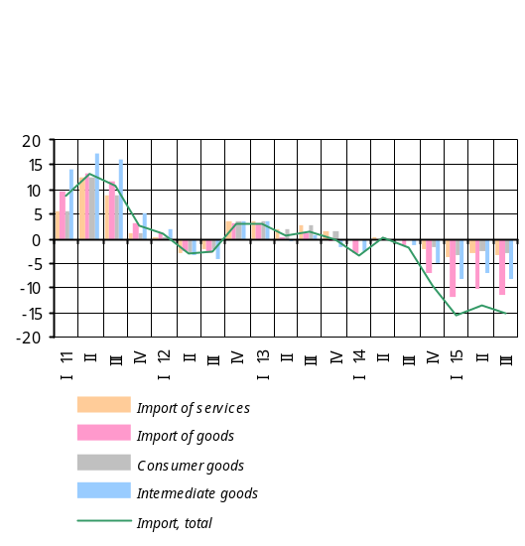 The y/y reduction in dollar prices of import was driven by prices of goods and services having fallen by 11.6 and 3.5 pp, respectively. The y/y decrease in dollar prices of import of goods was determined mainly by y/y decline in prices of intermediate goods. Overall, this is explained by falling oil prices and depreciating currencies in trade partner countries.
The y/y falling in dollar prices of consumer goods was driven largely by y/y decrease in dollar prices in the Eurozone, Russia and Turkey. As a result, consumer goods had a 3.2 pp of negative contribution.
Producer prices: in the period January-September of 2015, all sectors of the economy, with an exception of agriculture and mining sub-industry, posted increased price indices. As a result, the growth of GDP deflator amounted to 3.3% y/y, according to the CBA estimates.
Industry had no price changes reported in the period January-September, since growths in processing industry (3.8%) and energy and gas production and distribution (4.0%) have been offset by 18.0% decline in mining sub-industry, which was driven by falling prices of ores and metals in world markets.
Agriculture reported a 21.8% y/y drop in prices driven by as much as 39.0% y/y decline in prices in plant growing as a result of abundant crops. In the same period of time, there has been somewhat a smaller decline in prices in animal breeding, by 3.2% y/y.
The price fall in plant growing has been largely driven by decreased prices of fruits and berries (56.2%) and potato and gourds and melons (1.5%), and grain (16.3%).
Services reported a 3.2% y/y rise in prices in January-September, determined by growths in household services (6.3%), medical services (5.0%), recreational services (22.5%) and public catering services (8.4%). The slackening of domestic demand observable since the start of the year to the period under review has markedly affected transport and communications which posted, accordingly, a 2.2% deflation and just 0.7% inflation.
Construction reported a 6.6% y/y price growth in January-September, driven by increased costs in construction and assembly works (5.6%), equipment and materials (4.1%) and other related expenses (14.5%). Note that the inflation on other expenses is primarily due to a wage growth.
Carriage posted a 1.9% y/y rise in tariffs in January-September, owing to increased fare for railroad transport (11.2%) and truck transportation (0.7%). Note that higher railroad fare is mainly attributable to the electricity price increase.

3.1.3. Inflation and interest rate expectations
According to Q3, 2015 financial sector survey by the CBA, the households’ expectations of inflation for an upcoming one-year horizon have weakened to some extent but are still above the 4.0% target. This points to the tightness in domestic financial and foreign exchange markets amid increasing volatility in world financial and currency markets in August-September of 2015 on the one hand, and slow downside adjustment of product prices net of seasonal agricultural products along with sluggish domestic demand and deflationary external environment, on the other.
During the quarter, the CBA continued its surveys with the financial sector for their expectations of selected macroeconomic indicators. Although the financial sector’s inflation expectations for an upcoming one-year horizon have diminished to a certain extent, these are nonetheless rather sensitive. Thus, banks have their expectations of the 12-month inflation rate anchored around a 4.3% level against the 4.7% indicator reported in the previous survey; credit organizations’ expectations have averaged 4.7% compared to the previous indicator of 5.8% and households have their expectations of the 12-month inflation rate moved to a 3.6% level from the previous quarter’s 4.0%.
Expectations of interest rates in the financial market for a one-year horizon have somehow changed in relation to the previous survey. This quarter the financial sector anticipates a certain drop in interest rates of funds attracted and allocated, in local and foreign currency, which points to the markets rates trending downward in the last couple of months.

3.2. Aggregate supply and aggregate demand

3.2.1. Aggregate supply
The economic growth indicator for the first half of 2015 was 4.0% y/y, according to the National Statistics Service of Armenia. This indicator is higher from previous forecasts of the CBA, which is due to higher-than-expected growth reported in industry and services sectors in the first half of 2015.
In the period January-September 2015, the economic activity indicator has grown by 3.7% y/y, a slight outpace of expectations as a result of strong output volumes in industry and services. So, for the first nine months of 2015, the economic growth is estimated within 3.4 - 3.6%.
Given an increased output of 4.8% y/y reported in Industry in the first nine months of 2015, the growth of value added is estimated in the range of 5.6 - 6.0% y/y for the same period of time. This is mainly due to increased production in ore mining (41.7%), jewelry crafting (51.4%), tobacco production (52.8%), pharmaceuticals (27.5%), chemical products (8.6%) and water supply and sewerage (9.9%). High growth in ore mining is determined by the start of Teghout mine operation. Notwithstanding the growth recorded in the above sectors, a sluggish domestic demand in Russia, a principal trade partner, led to a decline in output volumes in several subindustries of the Armenian economy. In particular, production of food and beverage, which hold a significant share in industry, has shrunk by 6.3% and 21.5%, respectively, and negatively affected the growth in there.
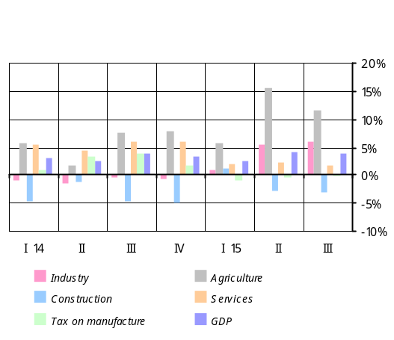 Based on actual developments (0.1% y/y) in Construction for the period January-September 2015, the decrease of value added is estimated within 2.7 - 3.6% y/y for the same period of time. The decrement has been due to about 10% shrinkage in construction financed by state budget, while construction financed by households and organizations posted growths of 14.4% and 0.2%, respectively.
In Services, the growth of value added in January-September 2015 is estimated in the range of 1.4 - 2.0%, which is a result of2.5% growth in services provided but 5.6% contraction in trade turnover in the same period of time. The increase in the volume of services provided was driven largely by growth reported in financial and insurance services (8.6%), events, leisure and rest services (69.3%), IT services (17.4%) and hotel and accommodation services (7.1%). Domestic demand, slackened as a result of a decline in money transfers, has negatively affected the trade turnover which, in turn, led to reduced output in transport sector. The volumes of retail, wholesale and passenger car trade have reduced by 7.6%, 1.9% and 8.6%, respectively. The volumes of trade in transportation have shrunk by 25.4%.
In Agriculture, the growth of value added for the first nine months of 2015 is estimated in the range of 11.2 - 12.0%, which is driven by increased outputs in animal breeding, plant growing and fishing by 4.1%, 15.0% and 26.0%, respectively.

3.2.2. Aggregate demand
The third quarter of 2015 saw the private spending reduced more (nearly 8.0%) than it had been foreseen in previous estimations. This is explained by more-than-anticipated shrinkage in private consumption, reaching an estimated 7.0%.
Reduced private remittances from Russia, a trend observable since the end of 2014, have notably diminished the households’ disposable income which,which in turn, led to the decline in private spending in 2015. It should be noted, however, that expansionary fiscal policy carried out by the Government in the period under review, easing of monetary conditions by the CBA, as well as a steady inflationary environment served a substantial cushion against declining private spending.
The results of the CBA surveys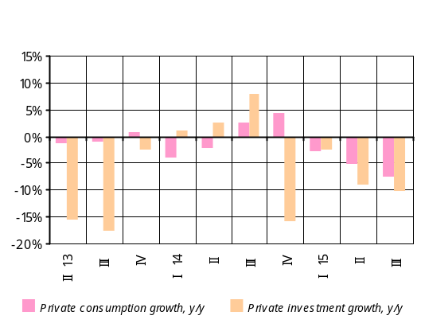 and trade turnover indices calculated by the National Statistics Service of Armenia point to the contracted consumption in the private sector. Thus, in the third quarter of 2015 the Consumer Confidence Index was 40.4, which is below its stability range of 45 - 55, reflecting shrinkage in consumer spending in the period under review. Note that in the third quarter, compared to the same reference period last year, trade turnover had shrunk by 7.2%, with a reported decline in wholesale and retail trade as well as motor vehicle trade.
In the third quarter of 2015, the investment climate in the economy was weak – consistent with the forecast – with an estimated 10.0% decline in private investment in relation to the same reference period last year. The decline was determined by reduced domestic demand, slower growth rates in company lending as well as generally a sluggish business environment in the period under review. It should be mentioned that the decline in investments was more pronounced in non-tradable sector of the economy, whereas investment activity was relatively strong in tradable sector.
The results of the CBA’s investment survey on Armenian companies point to the aforementioned developments in investment activity in the period under review. According to the results of the survey, in the third quarter of 2015, relative to the same reference period last year, the business activity indicators in non-tradable construction and domestic trade sectors reached 39.0 and 45.8, well below the stability point of 50.0. On the other hand, the business activity indicators in tradable industry and non-trade services sectors were above the stability point of 50.0, amounting to 52.4 and 60.3, respectively.
With private consumption and investment developments described above, private spending shrank by 7.8% in the third quarter; and while public expenditures posted about an 8% increase, domestic demand reported an estimated 6% decline, which is a smaller contraction relative to private spending.
In the light of the aforementioned developments, private spending gap in the third quarter of 2015 is estimated to be negative, and it created 2.4 - 2.6 pp of deflationary pressures in consumer market. The deflationary pressures, nevertheless, did not necessitate total price adjustments since, as estimations suggested, there were high inflation expectations in the economy in the period under review.
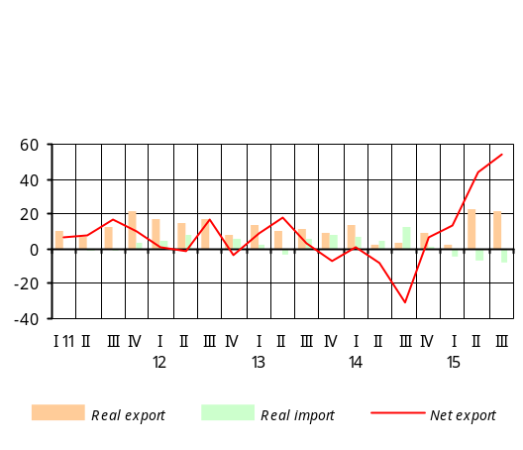According to the CBA estimates, net export in real terms further improved in the third quarter of 2015. This was driven by high real growth in export of goods and services in the face of real decline in import of goods and services. Thus, growth rates in real export of goods and services amounted to 21.4% y/y amid an 8.5% shrinkage in real volumes of import of goods and services. It should be noted that export of beverage to Russia has reduced but this setback has been offset by increased export to the Middle East.
The impact of net external demand is 0.3 - 0.4 pp inflationary this quarter, which is determined by much deeper negative import gap, concurrent with an estimated negative export gap.
In the third quarter of 2015, net inflow of non-commercial remittances of individuals via the banking system contracted faster than it did in the previous quarter. This was attributable to a new wave of depreciation of Russian ruble against US dollar as a result of adverse developments in Russian economy. In the third quarter of 2015, net inflow of non-commercial remittances of individuals shrank by 40.4% y/y.

3.2.3. Labor market
In the third quarter of 2015, the average nominal wage growth rate was in line with the previous forecasts, standing at 7.9%. In the meantime, growth rate in wages of public sector has been faster than wage growth in the private sector, due mainly to persisting high growth of wages in public sector in July.
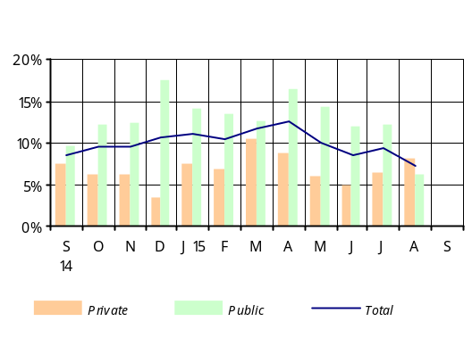The effect of wage increases in some areas of public sector since July of 2014 phased out in the third quarter of 2015. As a result, the average annual wage growth in public sector slowed down to 8.2%.
The average nominal wage growth rate in private sector outpaced the growth rate recorded in the same reference period last year; it reached 7.5% in the third quarter of 2015 owing to increased productivity. Over the same reference period of 2014, the average private sector wage had risen by 6.7%.
The second quarter of 2015 saw an increase in productivity which persisted over the third quarter, too. This resulted in reduced labor demand in the economy. Therefore, in spite of accelerated economic activity, the productivity growth helped the unemployment rate to post a 0.6 pp growth in the third quarter, compared to the same reference period last year, to 17.7%, which is consistent with previous forecasts.
In the period under review, the productivity growth has been faster than the wage growth, which led to reduced unit labor costs and increased competitiveness. As a result, the labor market’s impact on inflation in the third quarter of 2015 is estimated 0.2 - 0.3 deflationary.

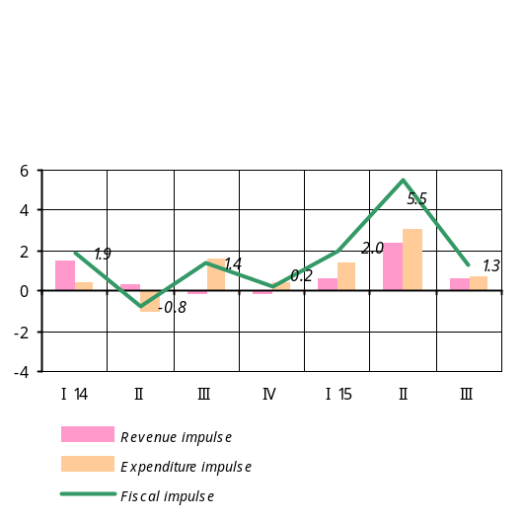3.2.4. Fiscal policy
In the third quarter of 2015, the Republic of Armenia state budget performed with revenues under-collected and some money saved on certain expenditure items. In terms of the CBA projections, the revenues were under-collected as well, while expenditures came in slightly outnumbered. In the third quarter of 2015, the fiscal sector’s impact on aggregate demand was 1.3 expansionary instead of an expected 0.9, according to the fiscal impulse indicator.
In the period under review, relative to the same reference period last year, revenues of consolidated budget have grown by 3.4%. In the meantime, tax revenues have increased by 2.1% y/y. The amount of actually collected tax was roughly AMD 25.0 billion less than the adjusted quarterly plan and AMD 7.2 billion less than the CBA projection. This is why the revenue impulse totaled 0.6 expansionary instead of projected neutral.
In the third quarter of 2015, the fiscal sector’s impact on aggregate demand was 1.3 expansionary instead of an expected 0.9, according to the fiscal impulse indicator.
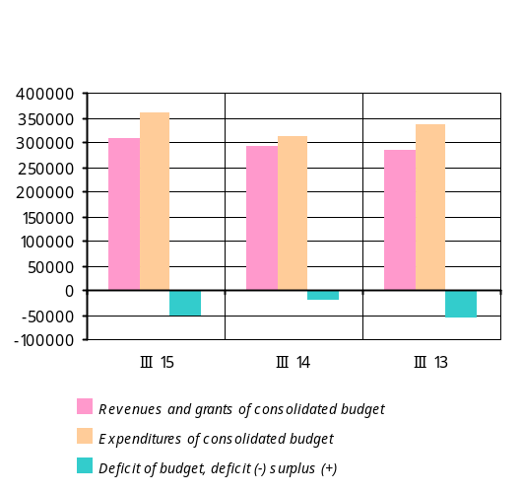With economic activity slowing down, indirect taxes have increased by a mere 2.9% in relation to the third quarter of 2014, whereas direct taxes remained unchanged. The share of indirect taxes in total taxes and duties has grown by 0.5 pp to 53.4%; the share of direct taxes has reduced by 0.7 pp to 36.6%, and the share of other taxes has grown by 0.3 pp to 10.0%. Other revenues have grown by nearly 44.5%, outstripping the current quarter’s projection.
Government spending was lower from the projected figure adjusted for the third quarter; it amounted to 90% of the projection.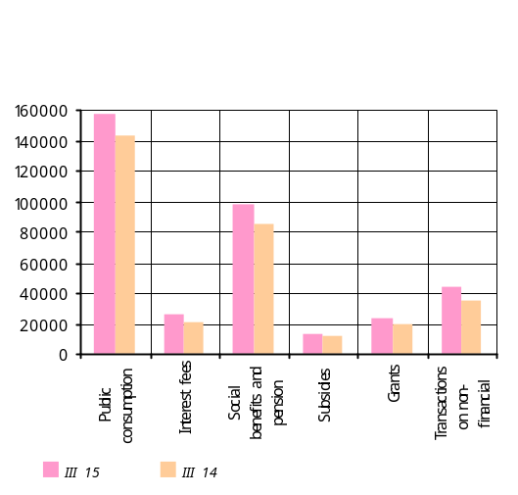 The third quarter’s expenditures were in line with the CBA projection. There was nearly 15.2% increase in consolidated budget expenditures relative to the same reference period last year. Current expenditures have grown by 13.6%; note that the growth has been reported for all items. Public consumption has increased by 10.4% compared to the same reference period last year. Expenditures on item “Transactions with non-financial assets” have grown by 28.5%, which is explained by increased capital expenditures financed from domestic sources.
With revenue and expenditure figures shown above, the state budget generated a deficit of AMD 52.7 billion in the third quarter of 2015.
According to the results of the past nine months, in view of economic activity slowed down in relation to the economic growth outlined in the Law on “State Budget 2015”, tax revenues of the state budget amounted to 94.1% and public expenditures, 91.4% of the adjusted plan. Compared to the same reference period last year, tax revenues have grown by 1.3% and Government spending (including PIU funds) have increased by 15.2%.
According to the results of the past nine months, the deficit of state budget amounted to AMD 112.8 billion instead of AMD 147.0 billion as outlined in the adjusted plan.
Overall, the fiscal policy’s impact on aggregate demand has been 2.8 expansionary, with expenditures and revenues having generated, respectively, 1.6 and 1.2 expansionary effects.
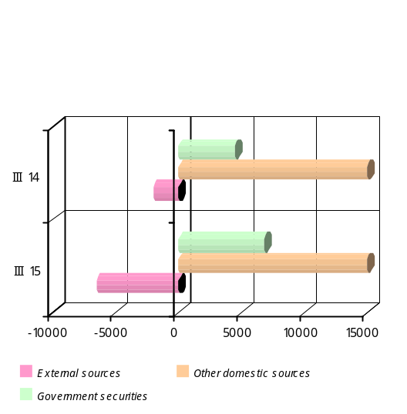 Summary: reduced private transfers from Russia as well as sluggish investment activity in the domestic economy have curtailed spending in the private sector. However, the contraction of expenditures in private sector has diminished owing to fiscal stimuli provided to the economy and loosened monetary conditions in 2015, which, in turn, has softened the domestic economic slowdown and deflationary environment.
In the third quarter of 2015, private spending gap is estimated to be negative. Given that public spending and net exports had inflationary patterns but the labor market followed predominantly a deflationary path, it is estimated that the aggregate demand and labor market combined have created 1.7 - 1.9 pp of deflationary pressures in the consumer market in the third quarter. However, the deflationary pressures described above have not been fully absorbed in the consumer market because the economy was still subject to high inflation expectations.

3.3. Money and financial market developments
The financial market reacted to the CBA policy through a steady trend of falling interest rates.
3.3.1. Financial market, money and credit
In view of stable inflation forecast in early third quarter of 2015, the Board of the CBA decided to loosen monetary conditions by lowering the refinancing rate by 0.25 pp to 10.25% in August. 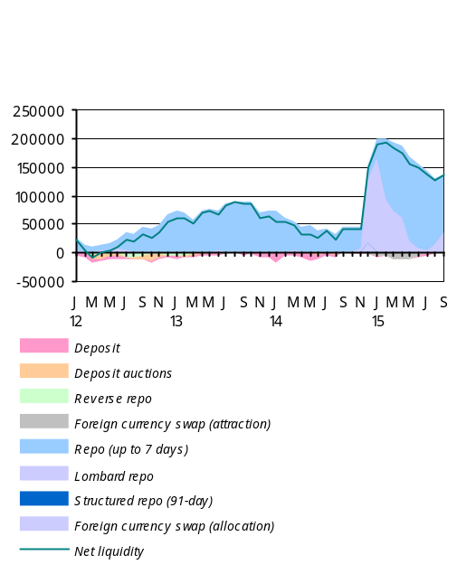The financial market responded to this policy of the CBA by demonstrating a trend of falling interest rates. Increased volatility in world’s financial and currency markets in the second half of the quarter created relatively high inflation expectations, which did not allow the CBA to ease the conditions further. The Board of the CBA found it reasonable to keep refinancing rate at its current level to minimize and anchor the inflation expectations in an upcoming period of time and fulfilling the inflation target in the medium run. The expectations shaped in the meantime have led to an increased demand for dram and, notwithstanding an unchanged refinancing rate, interest rates rose and adjusted in late September only.
In the third quarter of 2015, relative to the same reference period last year, the rate of CB main instrument - 7-day repo rate- has dropped by 0.3 pp to 10.72%. Though the rise in interest rates of liquidity provided by the CBA pushed the average monthly indicator up in September, the interest rate again fell at the end of September to 10.54%, approaching the policy rate of the CBA.

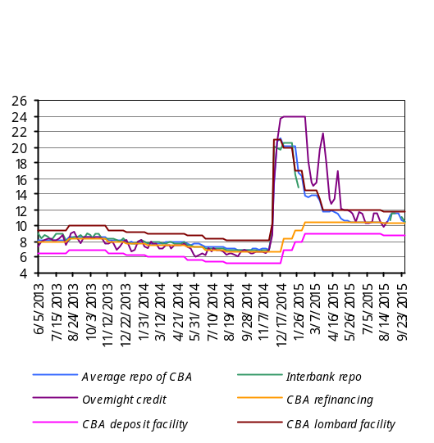
Box 2
Reserve requirement

In view of tension in global financial and currency markets at the end of 2014, the CBA used reserve requirement mechanism to manage liquidity for monetary policy purposes.. In mid-December, the RR ratio for for foreign currency liabilities was raised from 12 to 24% but late in the month, following signs of some stabilization in the foreign exchange market, the CBA lowered the same ratio from 24 to 20%.
As the financial market stabilised, the CBA repeatedly looked to the lowering of RR ratio during 2015:
- a zero or loose mechanism of reserve requirement for long-term funds in foreign currency attracted by banks became effective on March 1, 2015,
- a decision in late June of 2015 endorsed a change in approach to keeping reserves against funds in foreign currency attracted by banks: from July of 2015 reserves are kept on average weekly basis. The daily basis to keeping required reserves was abandoned.
- since August of 2015, banks have switched to keeping required reserves on a two-weekly averaging basis.

Operations carried out by the Central Bank (average transaction value)
Period | Repo (up to 7 days) |  | Funds attracted |  | Lombard repo
Period | Value  (million AMD) | Weighted average % | Value  (million AMD) | Weighted average % | Value  (million AMD) | Weighted average %
Q1, 2014 | 58769.52 | 7.80 | 8230.77 | 6.17 | 297.76 | 9.05
Q2 | 41619.24 | 7.79 | 9908.46 | 5.88 | 41.38 | 8.75
Q3 | 37331.05 | 7.16 | 3270.00 | 5.47 | 16.08 | 8.43
Q4 | 34048.94 | 10.60 | 1765.67 | 5.25 | 41550.14 | 19.69
Q1, 2015 | 95454.55 | 14.25 | 63.75 | 8.04 | 104521.49 | 16.27
Q2 | 141919.97 | 11.02 | 1857.26 | 9.00 | 27967.60 | 12.00
Q3 | 119429.03 | 10.72 | 3639.62 | 8.95 | 17089.82 | 11.78

In the financial market in the third quarter of 2015, interest rates of other instruments trended in line with the policy rate of the CBA. In August, interest rate of overnight credit came up to the policy rate of the CBA, yet a complete picture of the quarterly indicator cannot be reached because of the lack of transactions on that platform since mid-August. Meantime, some renewed activity was seen in the interbank repo market where interest rates have also shaped around the main instrument of the CBA: in late September the interest rate was 11.41%.
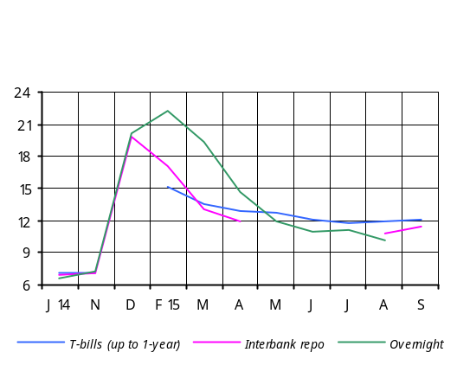

Box 2

Government securities market
The third quarter of 2015 marked a narrowing of yields in the government securities market. Average quarterly interest rate of short-term T-bills fell by 0.7 pp against the previous quarter to 11.9%; the decrease in September has been 0.1 pp relative to June.
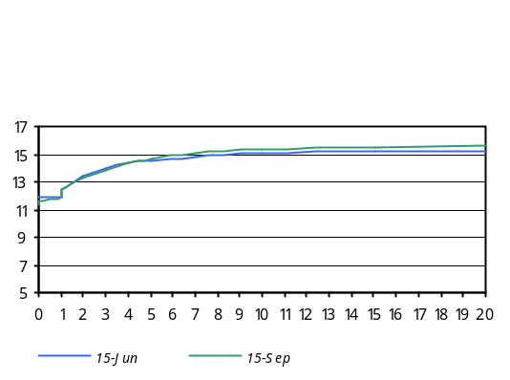The falling of short-term interest rates in the third quarter of 2015 also reflected a yield curve for government securities through reduced yields in a short-term segment and an up-sloping curve. In late September, compared to June, the yield curve has increased slightly the entire length: the long-term rate reached 15.6%, a 0.4 percentage point increase against June, whereas the long-term and short-term interest rates spread widened in September by 0.9 pp to 4.2 pp.

In the third quarter of 2015, interest rates of deposits and loans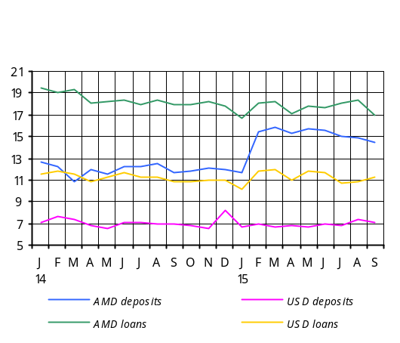 trended the way they did in the previous quarter. In the banking sector, interest rates of dram deposits declined by 0.7 pp to 14.8% in the third quarter. In September, relative to June, the average interest rate has dropped by 1.0 pp to 14.5%. A low level of dram liquidity implied that interest rates of loans in local currency would grow high, which was the case especially in July-August of 2015. As a result, the average quarterly interest rate of dram loans has increased by 0.2 pp against the previous quarter to 17.8%; in September, relative to June, average interest rate had dropped by 0.8 pp to 16.9%.
In the third quarter of 2015, low interest rates of funds attracted in local currency affected their volumes: the dram deposits have reduced by 1.0% in volume.
The repeated easing of reserve requirement mechanism for foreign currency funds in the third quarter of 2015 resulted in an increase in interest rates and volumes of foreign currency deposits. In September, relative to June, average interest rate of foreign currency deposits has risen by 0.2 pp to 7.1. In the meantime, average quarterly rate has grown that much to 7.0%, while the volume of foreign currency deposits expanded by 4.0%.
Regular easing of the reserve requirement mechanism for foreign currency funds by the CBA in the third quarter pushed interest rates of FX funds up and led to expanded volumes of FX funds.
Interest rates of foreign currency loans further trended downward during the quarter as banks kept on cutting the costs related to attracted foreign currency funds. In September, compared to June, average quarterly interest rate has reduced by 0.5 pp to 11.22%, with the quarter’s indicator having averaged 10.9%. The decrease against the previous quarter was 0.6 pp mostly owing to the loans with more than 1-year maturity.
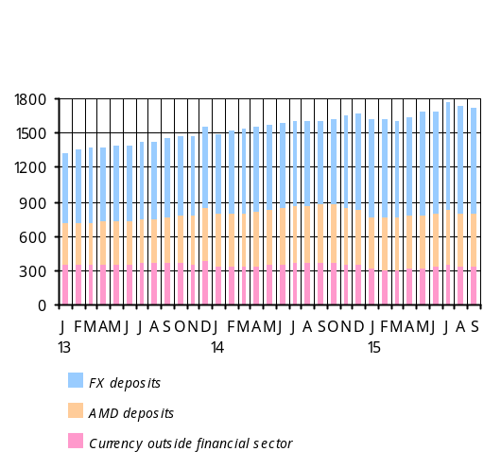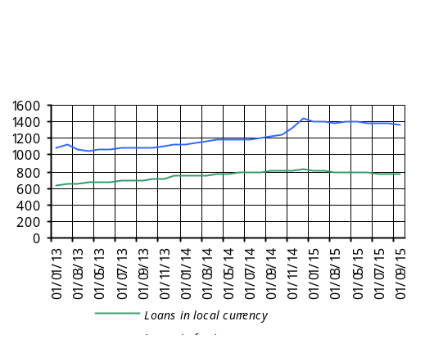 One may conclude, therefore, that the decline in short-term rates in the financial market and, in part, facilitated reserve requirement mechanism for long-term foreign currency funds have pushed interest rates of local and foreign currency loans down during the third quarter, too. Lending growth rates kept on decelerating in the third quarter of 2015, with September growth amounting to 6.3% y/y. Loans in foreign currency posted growth of 11.7% while loans in local currency reported a 4.3% decline. In the third quarter of 2015, the volume of loans contracted by 0.9%, with the volume of loans to households having shrunk by 2.1%. On the contrary, the volume of loans to companies grew by 0.9%. Note that the loans in foreign currency further prevail (approximately 64%) in total lending portfolio. The surveys conducted among banks in the third quarter suggest a acceleration of lending in the next quarter.

Box 4

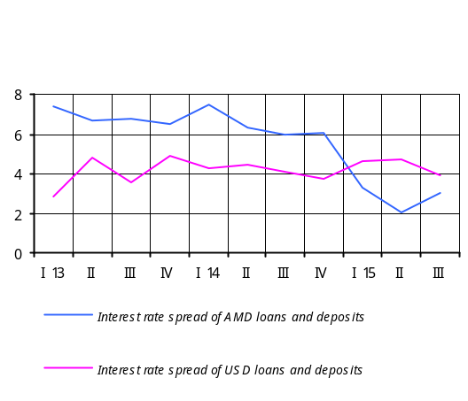 According to the results of the third quarter of 2015 survey on terms of lending by Armenian banks and credit organizations, starting from the fourth quarter of 2014 the terms and conditions for business and mortgage lending were less tight. Moreover, some easing began to be applied to consumer lending procedures, especially in respect of lending interest rate and non-interest pays.
Commercial banks and credit organizations have the following expectations for the fourth quarter of 2015: they anticipate some easing of procedures for all types of credit. Demand is expected to grow for household loans only, whereas demand for business loans is predicted to decline.

In the third quarter of 2015, the spread of interest rates of loans and deposits in foreign currency narrowed: the average quarterly indicator has dropped by 0.8 pp against the previous quarter to 3.9 pp. Contrariwise, the spread of interest rates of loans and deposits in local currency widened, driven by notable falling of interest rates of dram deposits and a slower decline in interest rates of dram loans: the average quarterly indicator has increased by 0.9 pp against the previous quarter to 3.0 pp; in September, relative to June, it has grown by 0.2 pp.
The inflation expectations, which grew more in the third quarter, led to the tightness in the foreign exchange market. This pushed the indicator of dollarization (the FX deposits-to-Broad money ratio) up by 1.2 pp in the third quarter compared to the previous quarter.

Monetary indicators | September 14, 12-month growth | December 14, 12-month growth | March 15, 12-month growth | June 15, 12-month growth | September 15, 12-month growth
Broad money (%) | 9.64 | 8.34 | 4.1 | 6.3 | 7.3
Dram broad money (% ) | 14.15 | -3.51 | -4.4 | -4.2 | -8.6
Base money (%) | -0.52 | -0.15 | 1.61 | 14.7 | 22.1
Dram base money (%) | 0.63 | 15.53 | 19.64 | 19.6 | 15.7
Currency (% ) | 1.44 | -9.39 | -9.8 | -6.7 | -10.6
Deposits in local currency (% ) | 25.31 | 1.37 | -0.5 | -2.5 | -7.2
Deposits in foreign currency (% ) | 4.71 | 22.74 | 13.0 | 17.9 | 26.2
Dollarization (percentage point) | -2.15 | 6.0 | 4.2 | 5.2 | 8.05
Money multiplier (percentage point) | 0.21 | 0.15 | 0.0 | -0.16 | -0.27
Dram multiplier (percentage point) | 0.17 | -0.22 | -0.28 | -0.29 | -0.30

3.3.2. Exchange rate
In the third quarter of 2015, trading partner countries saw depreciation pressures in their foreign exchange markets. The average weighted nominal exchange rate of the partner countries depreciated further, by 4.4% q/q, in the third quarter of 2015, after some appreciation in the second quarter. This was driven largely by depreciation of the Russian ruble (contribution: 3.7 percentage points). With partner countries’ national currencies depreciating, the average nominal exchange rate of the Armenian dram posted 0.6% q/q depreciation in the third quarter. The level of financial dollarization has grown in the meantime. The CBA has sold dollars in the amount of nearly USD 82 million in the foreign exchange market in order to absorb any short-term volatilities in there.
Driven by higher depreciation of a currency basket in partner countries, the nominal effective exchange rate of the Armenian dram posted 4.0% q/q appreciation in the third quarter. So, in spite of notable reduction of the inflation rate in the Armenian economy, the real effective exchange rate has appreciated by 1.0% q/q. The real exchange rate appreciated along with rapidly improving position of current account and increased productivity in the tradable sector of the economy.
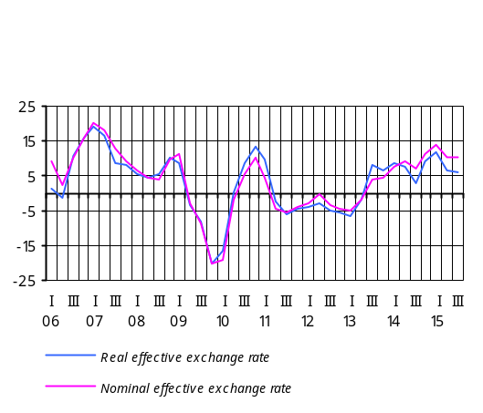 In the third quarter, relative to the same reference period last year, the real effective exchange rate has appreciated by 6.2%.

Growth y/y, (%) | Q3, 2013 | Q4 | Q1, 2014 | Q2 | Q3 | Q4 | Q1, 2015 | Q2 | Q3
Real effective exchange rate (+ means appreciation) | 7.9 | 6.8 | 8.5 | 7.8 | 3.1 | 9.2 | 11.7 | 6.7 | 6.2
Average inflation in Armenia | 8.7 | 6.4 | 4.6 | 3.3 | 1.0 | 3.2 | 5.2 | 5.1 | 4.0
AMD/USD average nominal exchange rate (+ means appreciation) | 0.5 | 0.2 | -0.4 | 0.5 | 0.0 | -5.7 | -13.9 | -13.4 | -14.8
Average weighted inflation in trade partner countries | 4.3 | 4.0 | 3.7 | 4.4 | 4.6 | 5.1 | 6.7 | 7.9 | 7.3
Trade partners’ average weighted nominal exchange rate (+ means appreciation versus dollar) | -3.2 | -4.3 | -8.0 | -8.6 | -7.0 | -18.5 | -32.1 | -27.2 | -29.3
Real exchange rate appreciation = Inflation in Armenia + Nominal exchange rate appreciation – Trade partners’ average weighted inflation – Trade partners’ average nominal weighted exchange rate appreciation.

Box 5
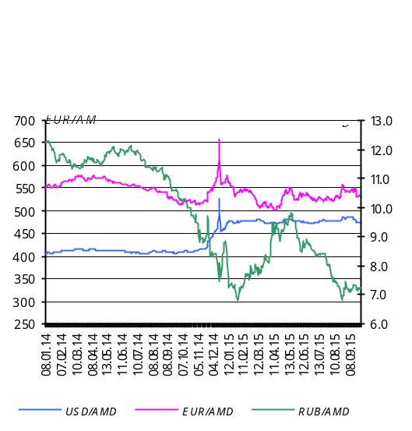 Foreign exchange market
As of end of the third quarter of 2015, the average market exchange rate of AMD/USD was 473.71, having depreciated by 0.25% relative to the end of the previous quarter.
Armenian dram exchange rate versus the U.S. dollar, Euro and Russian ruble during the third quarter of 2015 is presented in the table below:

The dram’s exchange rate: end of Q3, 2015 against end of Q2, 2015
Currency pair | Exchange rate as of 30.06.2015 (AMD) | Exchange rate as of 30.09.2015 (AMD) | % appreciation (+),  depreciation (-)
USD/AMD | 472.53 | 473.71 | -0.25
EUR/AMD | 528.48 | 531.36 | -0.54
RUB/AMD | 8.51 | 7.25 | +17.38

The dram’s average exchange rate: Q3, 2015 against Q3, 2014
Currency pair | Average exchange rate, Q3, 2014 | Average exchange rate, Q3, 2015 | % appreciation (+),  depreciation (-)
USD/AMD | 408.47 | 479.39 | -14.79
EUR/AMD | 541.37 | 533.33 | +1.51
RUB/AMD | 11.27 | 7.62 | +47.90

The aggregate volume of U.S. dollar/Armenian dram transactions in the foreign exchange market in the third quarter of 2015 amounted to USD 2.98 billion, which represents a 0.68% increase in relation to USD 2.96 billion reported in the same reference period last year.
The aggregate volume of Euro/Armenian dram transactions carried out during the quarter reached EUR 276.65 million, up by 0.13% against EUR 276.28 million recorded in the third quarter of 2014.
The aggregate volume of Russian ruble/Armenian dram transactions in the third quarter of 2015 totaled RUB 17.01 billion, which represents a 13.02% increase compared to RUB 15.05 billion recorded in the third quarter of 2014.

3.4. Balance of payments

The deficit of trade balance that kept on reducing faster because the diminishing of the dollar value of import accelerated was an important development in the third quarter of 2015. This quarter saw an accelerated decline in remittances of individuals compared to the previous one. This was attributable to a new wave of depreciation of Russian ruble against US dollar amid adverse developments in the Russian economy. In the third quarter of 2015, the deficit of current account has reduced considerably relative to the same reference period last year, in spite of a narrowed inflow of non-commercial remittances of individuals.
The financing of current account deficit was facilitated primarily through foreign direct investment as opposed to the growth of net foreign assets of the private sector. As a result of the balance of payments developments, the CBA’s net foreign assets have increased.

Change in dollar value of export of goods and services, y/y, and main commodity group contribution²⁶

Other
Transport means
Machinery and equipment
Non-precious metals and articles thereof
Precious and semi-precious stones, precious metals and articles thereof
Chemistry and related industry products
Ore and minerals
Products of prepared food
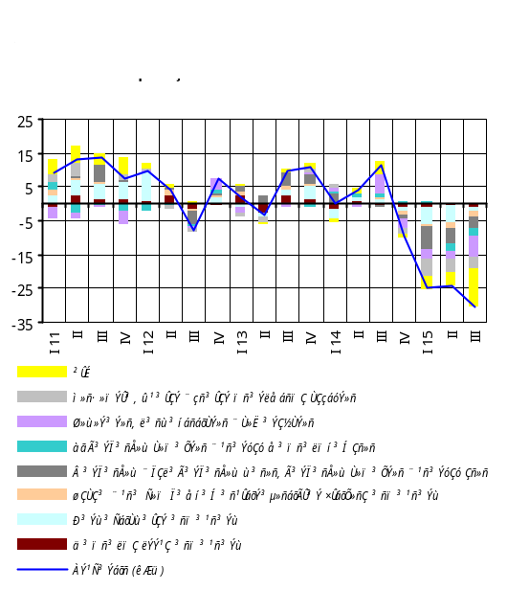
Total (CIF)
26

3.4.1. Current account
In the third quarter of 2015, relative to the same reference period last year, the Current Account Deficit-to-GDP ratio has reduced by 1.3 pp, according to estimates. In the third quarter of 2015, relative to the same reference period last year, the current account deficit has decreased by USD 115.0 million to USD 33.0 million.
In the period under review, the dollar value of export of goods has reduced by 4.6% y/y, which is explained by faster declining rates in export prices. The dollar value of import of goods has decreased by 30.8% y/y due to acceleration of declining rates in import prices, on the one hand, and contraction of real volumes, on the other.
Despite worsening terms of trade, the trade balance deficit shrank in the third quarter by USD 286.4 million to USD 256.4 million, as a result of high growth of real exports and reduced real imports.
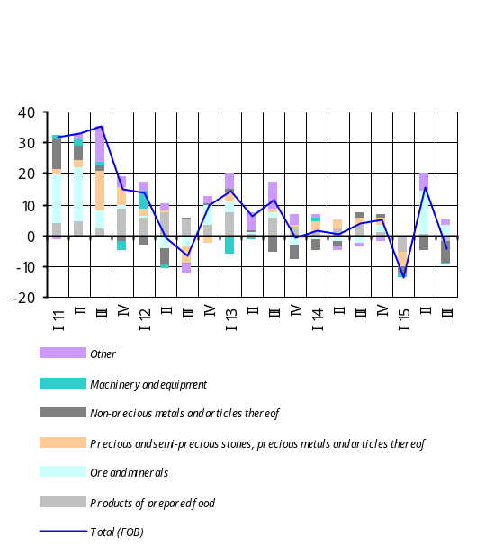 The decrease of the dollar value of export in the third quarter of 2015 was mainly due to the reducing dollar value of export of commodities, which primarily depends on the price developments in international commodity markets. On the contrary, consumer goods had positive contribution since export of the group “Textiles” has outpaced the decline of export of the group “Products of prepared food”.
The decrease of the dollar value of import during the quarter has been attributable to the contracted import of all commodity groups. The contraction was due to still sluggish domestic demand amid falling dollar prices of import.
The third quarter of 2015 saw a positive balance of services, amounting to USD 23.8 million. This was largely attributable to negative balance of transport services having reduced notably in relation to the third quarter of the previous year and to the growth of positive balance of travel. As a result, for the third quarter of 2015, export and import of services are estimated to have reduced, respectively, by 3.6% and 6.5% y/y.
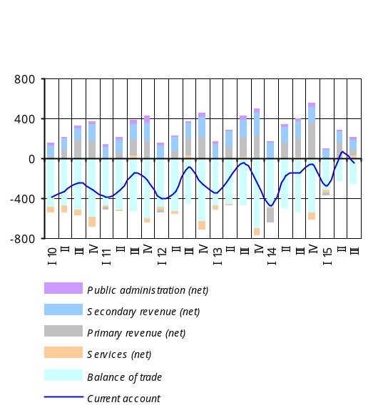In the third quarter of 2015, the narrowing of the inflow of remittances of individuals accelerated compared to the third quarter last year, which is explained by a new wave of depreciation of Russian ruble against US dollar in view of the developments in the Russian economy. Thus, net inflow of funds through item “Compensation of employees” posted a 39.0% y/y decrease to USD 197.4 million, which outgrew the figure of net outflow through item “Income on investment”. As a result, item “Primary income” posted net inflow of USD 67.1 million. Net inflow of private transfers has reduced by 44.6% y/y to USD 90.0 million.

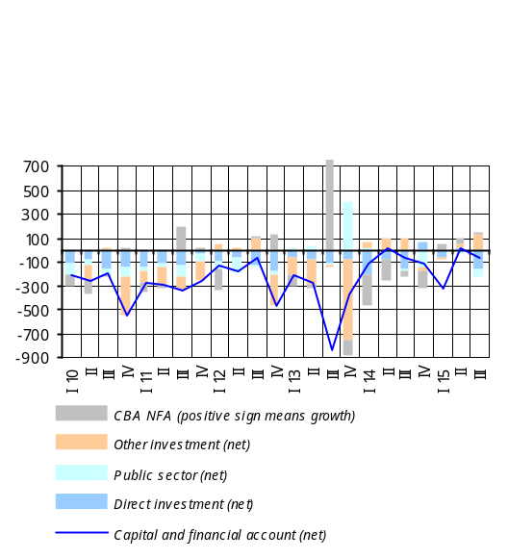3.4.2. Capital and financial account
In the third quarter of 2015, the net inflow of funds through the Capital and Financial Account amounted to USD 59.2 million, which is a decrement in relation to the third quarter of 2014. The current account deficit has been financed largely by foreign direct investment as opposed to the growth of net foreign assets of the private sector. As a result of the balance of payment developments, net foreign assets of the CBA have grown by USD 26.2 million.
In the third quarter of 2015, capital transfers amounted to USD 8.1 million against USD 17.0 million recorded in the same reference period last year.
The net inflow of foreign direct investments this quarter was USD 169.9 million, almost at the same level of the previous quarter. There has been a USD 56.6 million worth of net inflow of public credit against USD 20.3 million reported in the third quarter of the previous year.
Net foreign assets of the private sector have grown by USD 142.2 million in comparison with a relevant growth figure of USD 108.8 million in the third quarter of 2014. In the period under review, net foreign assets of commercial banks have reduced USD 93.2 million, whereas other private sector’s net foreign assets have grown by USD 235.4 million. Increased inflation expectations determined the accumulation of foreign currency assets in the private sector, hence an increase in the level of dollarization.

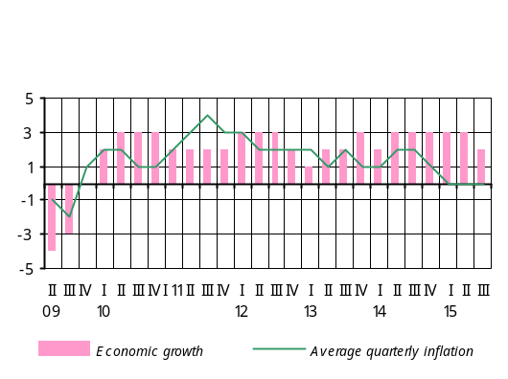3.5. External environment

The USA and Eurozone, principal trade partners to Armenia, further saw slow-growth patterns in their economies, while Russia, another principal partner, posted even deeper economic decline in the third quarter of 2015.
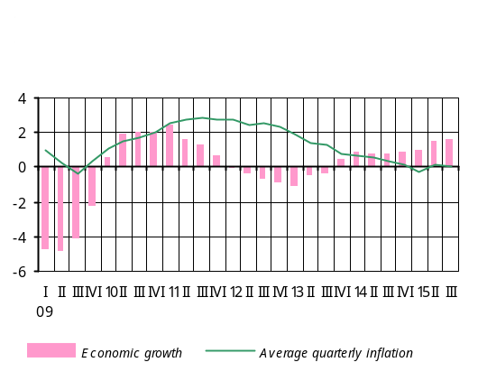 According to preliminary estimates of the U.S. Department of Commerce Bureau of Economic Analyses, in the United States of America in the third quarter of 2015 the annualized economic growth was 1.5% q/q against the previous quarter’s 3.9% growth (2.0% y/y economic growth was recorded in the third quarter compared to the previous quarter’s growth of 2.7% y/y). The third quarter’s growth was fueled by private consumption costs and public spending. Average quarterly inflation in the U.S.A. in the third quarter of 2015 was 0.04% y/y compared to the previous quarter’s deflation of 0.4% y/y. However, inflation remains well below its target. The U.S. Federal Reserve System still keeps the policy rates in the range of 0 - 0.25% in order to further sustain the labor market and regulate the inflation.
In Eurozone in the third quarter of 2015, there was 1.6% y/y economic growth against the previous quarter’s growth of 1.5% y/y, according to preliminary estimates provided by the Eurostat. In the third quarter, the inflation rate slowed down to 0.07% on average instead of the previous quarter’s relative figure of 0.17%. In the period under review, the European Central Bank kept the policy rate at the level of 0.05% and the deposit facility rate at the level of -0.2%. In addition to the program for buying asset-backed securities and covered bonds launched in late 2014, the ECB started another program in early 2015, which was aimed at buying sovereign bonds.
In the currency market in the third quarter, Euro appreciated against the U.S. dollar (q/q appreciation: 0.6%), whereas the European currency’s depreciation against the US dollar relative to the third quarter of 2014 has been 16.1%. The average dollar exchange rate reached 1.11 for one Euro.
In Russian Federation in the third quarter of 2015, there was a 4.1% y/y economic slowdown, according to the preliminary estimates of the Russian State Statistics Service (previous quarter’s decline: 4.6% y/y).
With the ruble exchange rate depreciated by 38.0% y/y in the third quarter of 2015, the 12-month inflation rate in Russia reached 15.7% on average compared to the previous quarter’s relevant figure of 15.8%. Note that, relative to the previous quarter, the ruble had depreciated by 17.0%. In view of slowing economic growth, the Central Bank of Russia lowered the policy rate to 11.0% in the third quarter from 11.5% at the end of the previous quarter.
In the third quarter of 2015, the price of Brent crude oil at Intercontinental Exchange fell by nearly 19.6% against the previous quarter to roughly USD 49.9 a barrel (with 51.1% y/y decrease), following the information about sizable production volumes and existing U.S. inventories as well as in anticipation of huge production volumes in future.
In the third quarter of 2015, the price of copper at the London Metal Exchange fell by 13.0% q/q (with 24.7% price decline y/y) to USD 5265 per ton on average. The factors that affected the deflation included an abrupt slowing of industry in China and large inventories.
In the third quarter of 2015, export price of hard red wheat kept on reducing, by 15.2% q/q to USD 4.98 a bushel (with 30.1% decline y/y), according to the U.S. Department of Agriculture data. The price falling this quarter is explained by large worldwide production volumes and sizable inventories.
In the third quarter of 2015, the price index of unprocessed sugar at the New York Board-Intercontinental Exchange posted an 8.2% decrease q/q (with 34.6% decline y/y). The price falling is due to increased production volumes in India and Brazil.
In the third quarter of 2015, the price of rice at the Chicago Board of Trade dropped by 2.1% to USD 16.9 per U.S. hundredweight (45.4 kg) (with 14.1% decline y/y), amid larger production volumes.
Deflationary trends were further observed in world’s food product and commodity markets during the third quarter of 2015. While the falling of commodity prices was in line with this quarter’s forecasts, the price decreases of food products exceeded the predictions. More-than-predicted price deflation of food products is mainly attributable to much larger volumes of food production.
4. Conclusion

In external sector in the third quarter of 2015, external demand remained sluggish while deflationary patterns were observable in basic commodity and food product markets of the world. In the forecast horizon, inflationary pressures from the external environment are not likely.
In the period January-September of 2015, growth of economic activity slightly exceeded expectations owing to higher-than-expected output volumes in industry and services sectors. Under this circumstance, economic growth in the third quarter of 2015 is estimated in the range of 3.4 - 3.6% y/y.
In view of predicted steady inflation environment along with weak domestic demand, the CBA loosened monetary conditions during the third quarter of 2015 by lowering the refinancing rate by 0.25 pp to 10.25%. In the period under review, the 12-month inflation rate followed a down-sloping path, consistent with the projection, reaching 3.3% in late September.
Economic growth in 2015 is expected in the range of 3.2 - 3.9%, mainly attributable to macroeconomic and financial stability since the beginning of the year, monetary conditions loosened by the CBA, more expansionary fiscal policy implementation as well as positive developments reported in agriculture.
In 2016, economic growth rates will continue slowing down. Starting from 2017 however, the growth rates will speed up, carrying the influence of effective implementation of the Government’s program steered to export and investment promotion, gradual improvement in the external economic environment and structural reforms. Driven by these developments, it is expected that economic growth at the end of the forecast horizon will be within 3.0 - 4.5%.
Thus, in the forecast horizon, as private demand stabilizes and the fiscal policy neutralizes, the impact of the domestic economy on aggregate demand will remain deflationary; it will be mitigated by the inflationary effect of net exports and phase out at the end of the forecast horizon.
At the end of the forecast horizon the 12-month inflation rate will stabilize around its target level of 4%. Weak domestic demand and external deflationary environment are still slow in reflecting the inflation indicator net of seasonal food products and regulated services, which implies that the inflation expectations remain high. The CBA estimates that inflation of that products will also reduce as inflation expectations diminish. At the end of 2015, the 12-month inflation rate will be at the lower bound of the confidence band; in the upcoming months it will persist at a lower level but is predicted to approach and stabilize around the target in the forecast horizon.
The CBA considers that loosening of monetary conditions in the fourth quarter of 2015, which could otherwise be sharper in case of low inflationary expectations, will result in expansion of aggregate demand and help the inflation stabilize around the target in the forecast horizon. In the fourth quarter, the CBA will keep on easing monetary conditions in the event inflation expectations are anchored and additional inflationary risks from both external and domestic environments are lacking.
Risks to inflation deviating from the projected value are estimated balanced in both short and medium-term perspectives. Risks deriving from the external sector are related to economic outlook in both developed and developing countries. In particular, there is risk that an expected hike in interest rates by the U.S. Federal Reserve System could lead to capital outflows from developing countries to the U.S.A. and provoke higher volatilities of currencies in developing countries. More pronounced are the risks to the further developments in Russian economy. These are attributable to oil prices with their deeper-than-expected decline and predicted lower level in the forecast horizon, continued depreciation of the Russian ruble, and a further course of geopolitical developments. A sharp slowdown in Chinese economic growth could also pose risks to the global economic decline and the fall in international prices of commodities and food products. Risks deriving from the domestic sector are dual-sided and mostly associated with the developments in agriculture, a sector greatly depending on weather conditions, the pace at which domestic demand and private investments will recover, as well as Government-led promotion programs. If the aforementioned risks materialize, the CBA will react accordingly by maintaining the inflation target in the medium run.

© The Central Bank of the Republic of Armenia, 2015

Vazgen Sargsyan 6, Yerevan, 0010. http:// www.cba.am

The forecasts of external sector were based on the information provided from international reputable analytical, research, ratings organizations and financial institutions as well as various news agencies worldwide (including the IMF, World Bank, The Economist, Economist Intelligence Unit, Global Insight, Financial Times, and so on).
See the 30% range in the Real GDP Growth (Cumulative) Projection Probability Distribution Chart.
See the 30% range in the Real GDP Growth (Cumulative) Projection Probability Distribution Chart.
See the 30% range in the Real GDP Growth (Cumulative) Projection Probability Distribution Chart.
See details in section “External environment”, chapter “Forecast, Forecast Changes and Risks”.
The labor market data for the third quarter of 2015 are the CBA estimates which are based on the second quarter of 2015 data and actual July-August 2015 figures. The growth indicators presented in this sub-section are relative to the same reference period last year, unless otherwise specified.
The data of real growth of private consumption and investments for 2015-2017 are the CBA estimates. These actual figures are as of the first quarter of 2015 published by the National Statistics Service of Armenia. The real growth indicators represented in this sub-section are relative to the same reference period last year, unless otherwise specified.
The 2015 GDP is the CBA forecast
The state budget indicators presented here exclude records of off-budgetary funds.
Estimations of the inflation indicator net of seasonal food products and regulated services are calculated and used by the CBA for a purpose of formulating and implementing a monetary policy. Specifically, this indicator is part of headline inflation that predominantly incurs the impacts of the monetary policy, and is calculated by excluding price inflation of seasonal food products (local fruits and vegetables, eggs, fish products) and regulated services from the headline inflation.
The price index change as of January-September 2015 is relative to the same reference period last year, unless otherwise specified.
Sales prices of producers of agricultural product are presented.
The CBA estimations of inflation expectations have been based on the Quarterly Projection Model of the CBA, under which the households’ inflation expectations are shaped through factors that affect both previous and future inflation period.
The indicators of y/y real growth of value added in sectors of the economy for January-September 2015 are the CBA forecasts, whereas the indicators of sub-sectors represent y/y growth rates in output volumes for January-March 2015, unless otherwise specified.
See the 50% range in Real GDP Growth (Cumulative) Projection Probability Distribution Chart.
The private spending, private consumption and private investment indicators for the third quarter of 2015 are the CBA estimates which are based on the second quarter of 2015 data. The growth estimates provided in this sub-section are relative to the same reference period last year, unless otherwise specified.
https://www.cba.am/am/SitePages/statsscci.aspx
Real export and import growth indicators are the CBA estimates.
The labor market data for the third quarter of 2015 are the CBA estimates which are based on the second quarter of 2015 data and actual July-August 2015 figures. The growth indicators provided in this sub-section are relative to the same reference period last year, unless otherwise specified.
The review of the fiscal sector was done using the preliminary actual consolidated budget indicators prepared on the basis of the preliminary actual indicators of the third quarter of 2015 (PIU funds included), excluding off-budgetary funds. The impact of revenues was calculated in respect of the nominal GDP indicator while the impact of expenditures, in respect of an estimated economic potential.
The Law on State Budget 2014 has been adjusted on a basis of Government decrees (https://www.e-gov.am/gov-decrees/).
The third quarter 2015 indicator of the real exchange rate is the CBA estimate.
The third quarter 2015 indicators are the CBA’s forecasts and estimates.
The export and import indicators are presented on a basis of the balance of payments, by the use of credit and debit, respectively.
The y/y decrement of dollar prices of export has outpaced the y/y falling of dollar prices of import.
The export and import indicators by commodity group are presented by prices FOB and CIF, respectively.
The third quarter of 2015 saw the net inflow of non-commercial remittances of individuals via the banking system shrink by 40.4% y/y.
The third quarter 2015 capital and financial account indicators are the CBA’s forecasts and estimates.

